1. **Content**: This document explains the EOrganism Enterprise MetaModel Software, Business functions and core functionalities plus **Business Value Propositions**. The Enterprise MetaModel is defined by TOGAF as mandatory tool inside the Enterprise and EOrganism is a direct and clear implementation for the requirement.
2. **Purpose**: This document will provide inside view and details about the EOrganism tool and business opportunities or the way the plus value is taken out of the tool and (IT) monetization (ROI) is easily achievable by using a TOGAF Enterprise MetaModel implementation.
3. **Context**: TOGAF – The Open Group for Architecture Framework governs and will define the proper standards and procedures the Corporations and IT organizations should operate and highlights the principles of IT and how is operated:

TOGAF Standard: <http://pubs.opengroup.org/architecture/togaf9-doc/arch/>

TOGAF Content MetaModel: <http://www.togaf.info/togafSlides91/TOGAF-V91-M7-Metamodel.pdf>

**Preview and Context:** Corporations today will employ a huge Enterprise having its departments at various locations, countries etc. Usually the today Enterprise is a highly segmented organization, operating independently with independent and non-coordinated towers or Business units, high bureaucratic operating and uncoordinated non-communicating towers. A very good example will be a major bank (CITI, TD Canada Trust, RBC, AXA, BMO) that will employ 2000+ IT Systems or Applications, 1000 + Databases with multiple schemas, 5000 Services (RMI, CORBA, WS, RESP, COM/ DCOM, SOAP WSDL, JMS, MQ, CTTL-M batches, MFT File interfaces, Email etc.), 50K + SOA Web Services operations, 100K DB Tables, 5 million DB Columns, 5K IT resources, 50 K Servers, 20K Database servers, 10 + Data Centers, multiple and various business lines, 20+ -100 million customers, 100K employees with 30 different business and IT locations in 10 countries, 200 vendors and 500 partners enterprises.

Overall with an IT budget of $500 mill, Company Revenues of $50 Billion USD and net profit of $10 Billion USD (Royal Bank of Canada) – IT Operations are a very serious and complex operation very difficult to control without a specialized Enterprise wide level software. There are millions of Metadata information elements flowing and not properly captured nor updated into a Central and Single Enterprise repository. Key to IT success today is to over deliver in time and budget, and reducing costs as much as possible. Time is money, searching for information will cost money.

To manage so many people and this amount of operations and data (metadata), the today Enterprise must have an Enterprise MetaModel already working and setup:

**Major Business events** – companies’ merges, major company product launches, business critical period for critical stability, major events

**Major IT and Technology Roadmaps / Projects:** Business Transformation, Data Center creation, Data Center migration, Cloud migration, SaaS, RESP Middleware Integration.

**Corporation’s Major events:** Tax submission (bank), RRSP contribution (bank), IPhone Launch (telecom)

1. **EOrganism functionalities:** EOrganism IT software is a (Cloud Web Based) direct implementation of TOGAF Content MetaModel, a specialized, dedicated tool for the IT Enterprises, usually consisting of 1000-2000+ Systems/ Applications (each with 5-20+ application components), 1000+ DBs, 2000+ (Web) Services endpoints, 100K -200K+ interfaces, 30K -100K + servers/ hardware, multiple mixed environments CLOUD, PROD, DR, QA, STAGGING, TRAINING, BCV, various Data Centers, multiple vendors 20K-200K employees and parallel aggressive project development possibly 50-100 Major projects Deliver/ year, periodical IT releases 4 +/ year, IT budget $ 200 mil- $ 800 mil/ year.

**EOrganism synonyms:**

* Enterprise Documentation Framework – *all project related documents will be centralized into one single Central Repository system – each document will be related to ORGANIZATION_UNIT, BUSINESS SERVICE, SYSTEM, APPLICATION, and PROJECT. Document types can be XML WS, XSD, Security Certificates, OSI, DDD, SDS, BRD, Production Support Documents, MOP, Support Manuals, Road Maps, DDD/ SDS/ OSI/ Architecture Standard Templates.*
* Technology Assets Management Repository – *centralized Web based enterprise tool capable of finding any asset and data inside the enterprise (Hardware, Application, database column, interface (Web service operation), sequence flow,*
* Centralized Live Project Support
* Centralized IT Project Repository – *central and single Web based enterprise tool for all searching all projects information, projects status, projects documents*
* Documentum
* Centralized Design documentation – *central system web based, cloud; searchable capable of searching all enterprise DDDs, based on various search criteria- application, project, content, flow, interface change, requirement, use case etc.*
* SDS Repository – a searchable Web Based (Cloud) SDS repository, to easily find any SDS information and any project/ application SDS file.
* Infrastructure Project Engagement Process -
* Data classification catalog
* Asset tracking
* License, Contract Tracking
* Tools
* Tools Information Repository – central archive and repository with search capabilities to extract information related to any IT asset and IT tool.
* Application Inventory classification – ITS Application repository Catalog
* Streamlined Intake Process Tool
* Centralized Standards, Processes and Templates - central archive and templates repository; central process documentation
* Streamlined IT Discovery
* Information and Project Sharing between projects -
* Interactive Project Directory and Historical Database – *Enterprise Projects repository Tracking and Documentation Tool*
* SDLC Documents and Templates
* Enterprise wide Search Engine Tool- *Enterprise Search Tool*
* Acronyms and Terms Dictionary
* Mapping Systems to Applications Visual -
* Integrated Environment Management tool
* Trace requirements to Use Cases tool
* Enterprise Process Repository Lexicon-Taxonomy
* Enterprise Communication status between running project
* Enterprise Project Management tool
* Universal CMBD
* IT Platform and Technologies Tool
* Centralized OSI repository
* Centralized Repository Tool
* Centralized IT Business functions Repository Tool
* Centralized list of IT Teams and systems
* Online Security Requirements tool
* IT Services and Support Inventory
* Web Services Inventory
* Oracle Enterprise Repository – OER
* Resource Management tool
* Centralized Knowledge Base Portal
* Centralized Assets Inventory Team/ tool
* Project Scope assessment and impact
* Document Interface specification
* Enterprise Architectural Assessment tool
* Internal Google Appliance Search
* Google Internal Search
* Network Inventory Management tool
* Record Asset Management tool

Some extensions have been applied on top of the TOGAF entities -RELEASE, ENVIRONMENT, and PROJECT. These entities are not present in the TOGAF specifications.

**METAMODEL**

1. Business Unit, Business Services, Business Processes
2. **Systems**, **Applications**, **Component**, **Services,** **Interfaces**, **Databases**
3. **Hardware**, Servers, Software
4. Environments (PRODUCTION, DR, BCV, non-PROD (QA, PET, UAT), TRAINING etc.)
5. Projects – PCR, MR, Business Transformation etc.
6. Releases – weekly/ monthly/ major Releases
7. Owners
8. Infra Systems - Network, Infra Systems – STORAGE, Infra Systems – Virtualization

**METAPROCESS**

1. **Sequence Flows** – how the systems are interacting at interfaces and data level
2. **IT Processes** – SDLC Processes, Support Processes, Release processes, ITPMO Office processes and standard, Architecture Processes, WA processes, HR processes etc.

**METADATA:**

1. Database metadata: how the data is structured in each schema, and all schemas in the enterprise
2. How data is transferred in XML format between the different applications and systems.
3. **EOrganism tool provides Business and IT functions, as per bellow:**
   1. **Systems, Applications, Components Inventory** – *EOrganism will use Automatic connectors to upload and maintain the “Enterprise Applications Inventory” possibly from existing CMDB DBs (IBM CMDB, ServiceNow CMDB), SharePoint (Excel File/CSV). Tool will provide a true Web Based Cloud access to all Metadata and can allow BI to be performed to IT systems data itself (Migration of Data Center, Business transformation analysis). Thera are many benefits and value of such inventory – e.g. function for Infrastructure Architects to map applications to existing hardware, network, databases, storage hubs, data centers; map Organizationl Unit to Systems, SCOA and costs, report of CAPEX project expenditures versus the production support OPEX, versus various Business Services, Revenues / Expenses.*

Cost to maintain this inventory 0.5 mill/ year.

* 1. **Hardware Inventory** - *EOrganism will use an automatic connector upload of Hardware/ Servers Inventory from CMDB DBs (IBM CMDB). This is an IT function to maintain the currency of the DB versions, OS versions, security patches, licenses, contracts and security certificates.*

Cost to maintain this inventory 0.25 mill/ year.

* 1. **Databases Inventory** - *EOrganism will use an automatic connector upload of Database Servers Inventory from CMDB DBs.*
  2. **Databases Metadata Enterprise Inventory** - *EOrganism will use an automatic connector upload and sync Enterprise Database Schemas from all master enterprise DBs* – load the DDL and unify entire Metadata Model at enterprise level; load all PL/SQL packages and all schemas objects, DB links etc. *Create the Data Flows and Graph of all Databases Data flows.*

Cost to manual discover the data repository and master data, data flows versus the projects delays

$0.25 mill/ year.

Cost to maintain and setup true and easy reporting, BI is $0.5 million/ year

1.5 **Services Metadata Enterprise Inventory** - - *EOrganism will use an automatic connector upload and sync Enterprise SOA Web Services Schemas and Services from published Web Service Locations URL WSDLs (PROD, QA, PET etc). Load will provide all WS operations, and SOAP Request*

*- Automatic upload inventory operations from existing CSV (JMS, RMI, CTRL-M, Batch Scripts, MFT, etc)*

*- EOrganism will load details from WebLogic SOA Consoles using MBeans connector.*

Cost to implement and setup true Enterprise Services Repository, Web Services Repository is $ 0.5 million.

Cost not having this Enterprise Services Repository, Web Services Repository implemented is $ 2 million/ year, due to projects time lost in analysis and repetitive discovery, flows discovery and validation.

1. **EOrganism ARCHITECTURAL ASSESMENT function:**

**Time is Money; time lost to find how is working, to assess the impact and produce proper planning, requirements, find exact enterprise flows and sequence of events– will generate resources idling, time lost generating increasing operational costs.**

**The Main Business function *- is a very accurate initial project Architectural assessment done using enterprise data and dedicated tool, versus human assessment based on not accurate and difficult to predict IT data.***

*A very clear and consistent example or Enterprise MetaModel can be found at AT & T – US Telecommunications Company.*

*AT&T had already developed internally an Architectural Assessment software, Java EE Web based application, very similar in nature and scope with a VIEWS of the TOGAF Content MetaModel concept. AT&T Architectural Assessment software is used by AT&T Enterprise Architecture (Enterprise Architects) and provides an early and pretty accurate assessment input to the Project Managers and Project planning/ Implementation team.*

* *Tool has static capability Architectural diagrams (images)*
* *Is not clear if the tool has DB repository other than static Architecture diagrams; tool doesn’t generate the diagrams dynamically from DB metadata MetaModel. Tool doesn’t generate Architectural assessment reports*
* *Tool has list of enterprise Applications, exposed interfaces, flows*

*Another example of a POC TOGAF Enterprise MetaModel can be found at Rogers Communications, biggest Media and Telecommunication Company in Canada. Rogers IT Architecture Governance group implemented a SOA Services enterprise Repository project using Oracle Enterprise Repository, later dropped due to inability to support Rogers Multiple environments and parallel multiple Releases – 2007-2008. The TOGAF Content MetaModel (SOA Services Repositories or aka Middleware WS Services Registries) future plans and next forecast is to implement Service and Application repository using (SNOW TCL) ServiceNow, already implemented for Service Management – Incident, Service Requests etc. Rogers is using ServiceNow CMDB as source for Applications/ Hardware Inventory.*

*Until a very expensive implementation is planned for Integration with Service Now, a parallel alternative cost effective and with quick ROI, small POC solution at Rogers is considered to use EOrganism for TOGAF Content MetaModel; this being the first enterprise wide implementation of EOrganism.*

* 1. EOrganism is specifically designed for Enterprise Architects to perform a **preliminary Architectural Assessment** overall the enterprise, ideal for large scale projects:

2.1.1 Business Transformation –Architectural Assessment

2.1.2 New Application promoted to the enterprise; Cloud SalesForce.com integration, Cloud ZUORA Salesforce billing

2.1.3 Migration or upgrade or existing applications – CURRENCY projects, LTS (Long Time Survival)

2.1.4 Datacenter migration – applications and infrastructure servers migrated from one datacenter to other data center, mainly upon vendor and outsourcing migration, companies merging, platform upgrades

2.1.5 Virtualization, CITRIX XenApp,

2.16 OS Desktop upgrades

1. **EOrganism SECURITY ASSESMENT function:**
   1. EOrganism maintains a full list of all applications, vendors, exposed services, exposed data and their ownership and location (e.g. and ideal tool for PCI compliance, Security governance, or monitoring all external HTTP locations, scanning all HTPPS location and notifying on SSL certificate expiration etc.)

Cost to manual perform and maintain security assessment (PCI, Customer Data) for various security driven initiatives is $0.2 million/ year

1. **EOrganism ENVIRONMENT MANAGEMENT function*:*** *Similar software tool like AMC - Amdocs Monitoring and Control, or Amazon Configuration management, SAP environment Management etc.*

Cost to manual maintain non-production environments for QA, PET is estimates $ 2 million/ year

Impact and cost of not having a non-production centralized DB and environment tool - environments for QA, PET, DR is estimates $ 0.5 million/ year

1. **EOrganism PMO, SDS, Design Documentation repository function*:*** *Similar software tools are - Wiki, Documentum, Sharepoint, IBM InfoCenter (BuildForge); all these tools are distributed not centralized and not searchable – one must know the exact location where to access (MW Wiki), then will have to browse folders until will find the desired document (SDS flow, servers/ HTML Excel list, deployment procedures etc). EOrganism is a centralized, Web based searchable Web based repository with enterprise wise search ability and capability. All Projects/ Applications documents centralized and accessible from one single location: SDS, DDD, PCR, MOP, Support Knowledge, OSI, Wiki. This is an IT PMO Functions, Architectural functions, Delivery and Support function*

Impact and cost of not having a centralized enterprise wide Documetation and Knowledge based (searchable) - $ 2 + million/ year

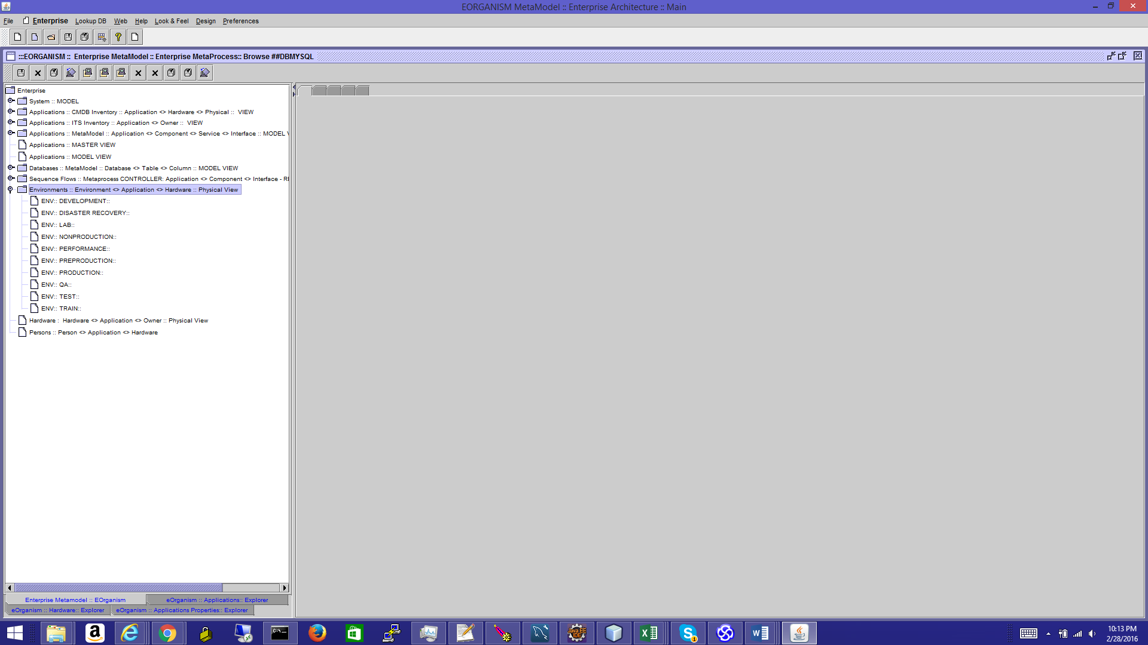

1. **EOrganism DEVELOPMENT**, **QA** **function:**

All sequence flows repository and all QA test cases repositories (aka QA Regression Test Cases Database).

1. **EOrganism CHANGE MANAGEMENT, INCIDENT MANAGEMENT** **function:**
2. **EOrganism KNOWLEDGE BASE function**: aka “How it works”, or “every data, everywhere to anybody”.

EOrganism will allow a quick search of every enterprise resource – from DB column, Web Services operation, Sequence Flow, up to Business Service to applications Flows, Hardware owner. Any process can be retrives from the metaprocess repository.

**OVERALL KNOWLEDGE BASE, DOCUMENTATION FRAMEWORK AND SEARCH ENGINE:**

Search on all IT services and IT interfaces

Search on all IT Database schemas and all environments

Search on all processes and documents, providing exact location and information

**Enterprise Applications Inventory** – *these inventory functions are presented and provided by Vendors like ServiceNow, CA- Computer Associates, etc.*

ESYSTEM, EAPLICATION, ECOMPONENT, ESERVICE, EINTERFACE, EATRIBUTE, EDATABASE, ETABLE, ECOLUMN

1. **EOrganism VIZUALIZATION, DIAGRAMMER OR DIAGRAM GENERATOR function:**

*Diagrams will be generated dynamically for DB model, Enterprise Sequence diagrams or Enterprise Architecture; most of the systems diagrams from SDS, DDD can be extracted and plug in from EOrganism Framework*

1. **EOrganism ENTERPRISE DOCUMENTATION AND GENERATOR function:**
2. **EOrganism APPLICATION MONITORING AND AVAILABILITY function:**
3. **EOrganism IT COST ANALYSIS function:**
4. **EOrganism IT GOVERNANCE function:**

Many other functions

**HOW IS WORKING**

*EOrganism will capture all the enterprise Metadata into a RDMS Database having all the Enterprise Entities:*

**ESYSTEM, EAPLICATION, ECOMPONENT**

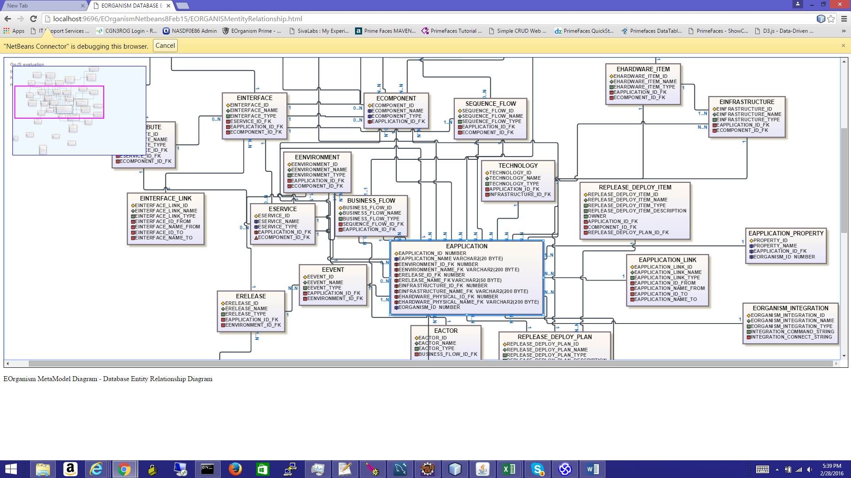



EOrganism will load from XML/ CSV/ Excel source (Sharepoint) or from Database Connector source (CMDB connector DB connect string Link) and will load into EOrganism DB into **ESYSTEM, EAPLICATION, and ECOMPONENT.**

**XML Loader format**

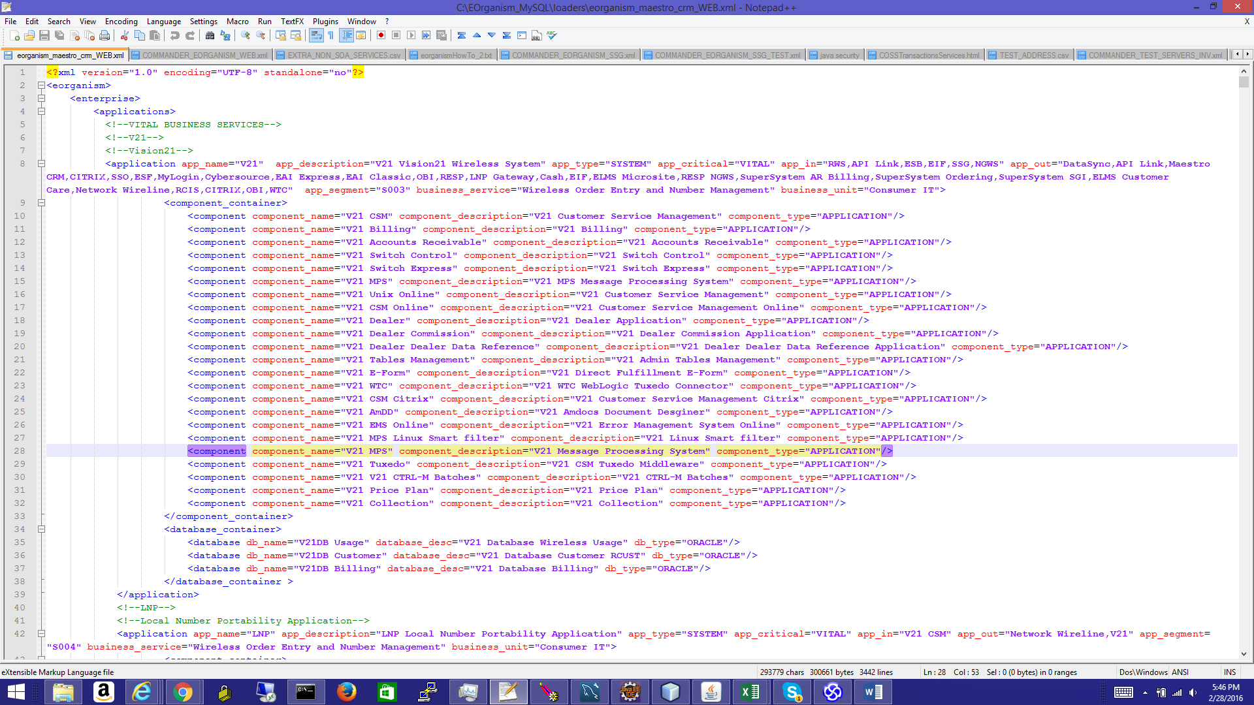

**CVS Loader format**

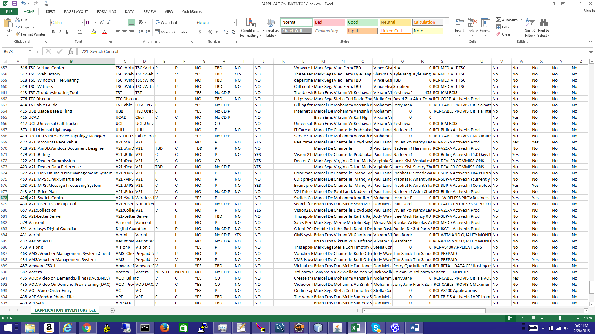

**EOrganism Swing ADMIN view -**

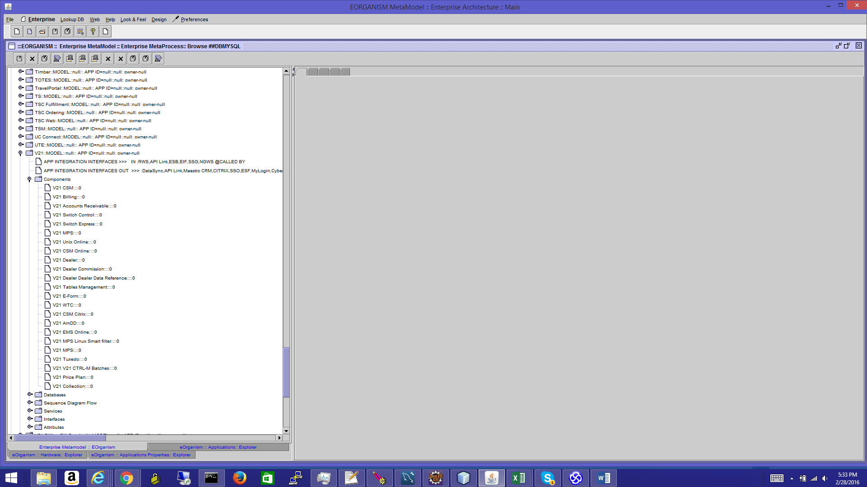

**EOrganism** **Web ADMIN view -**

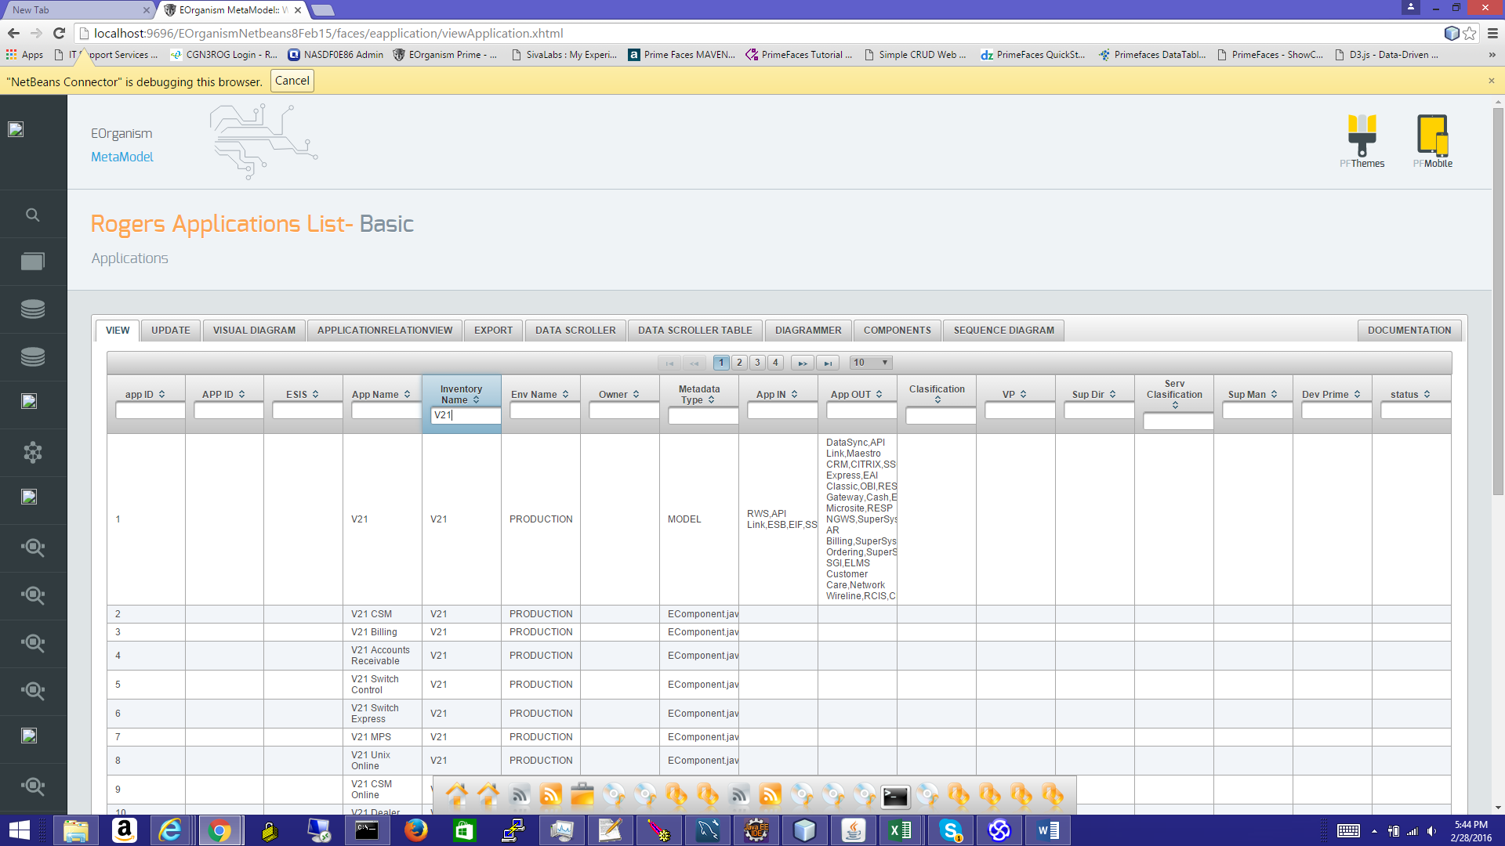

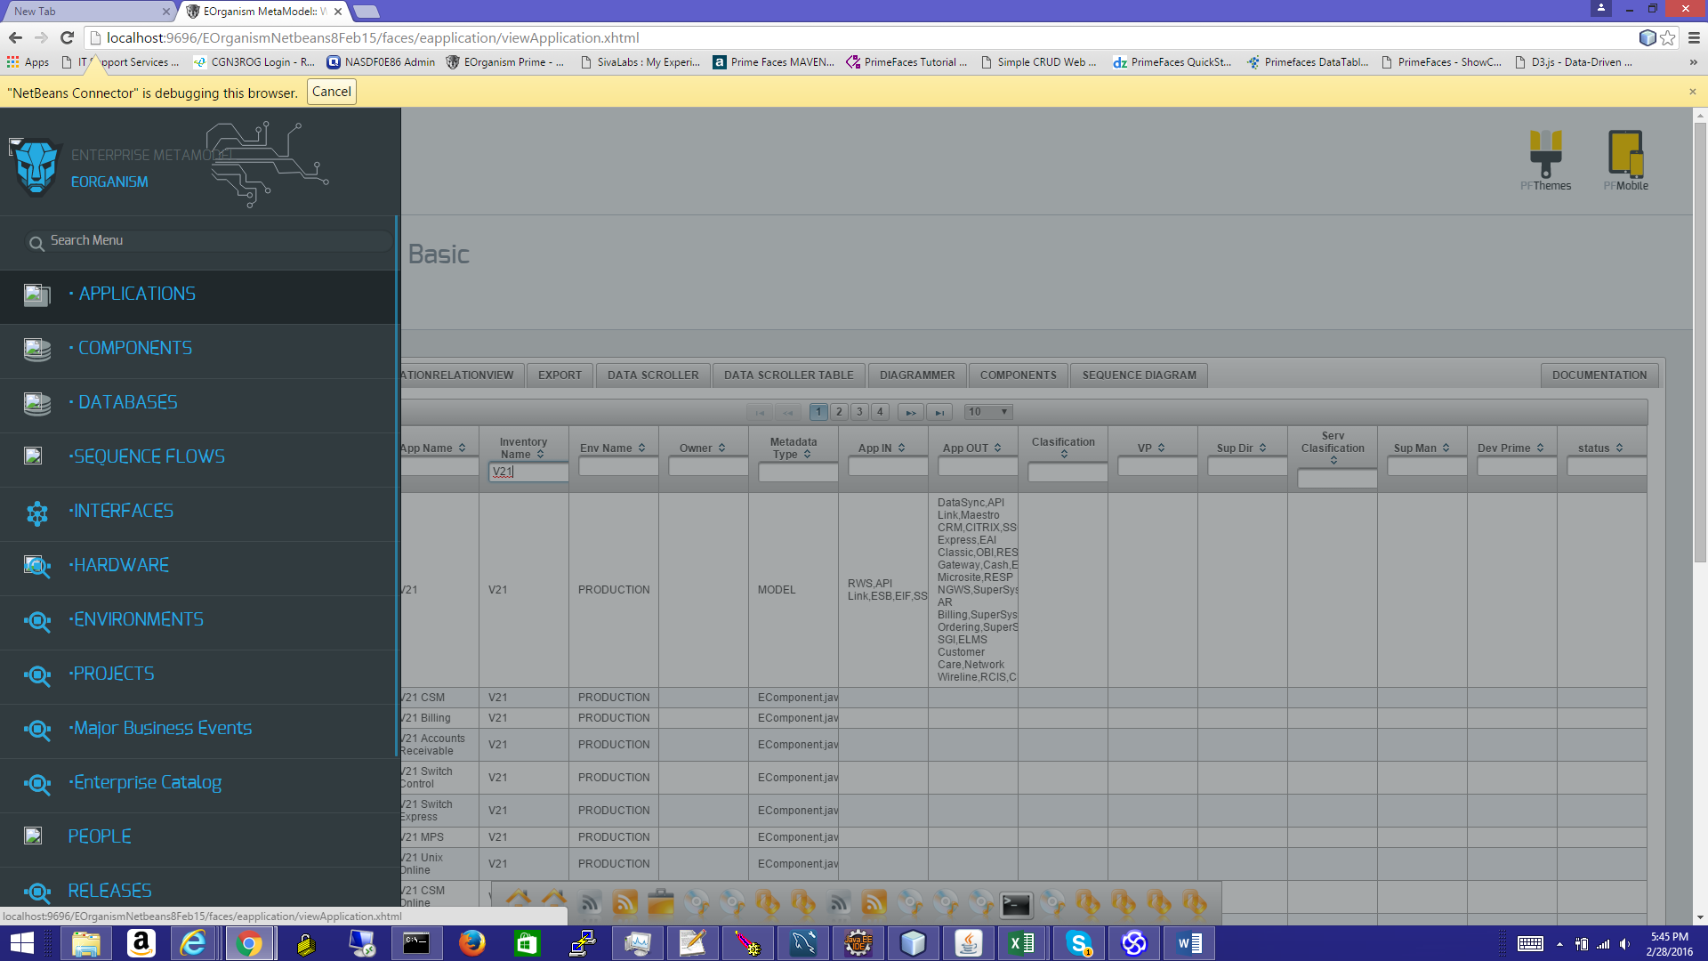

**EOrganism Data loaded view -**

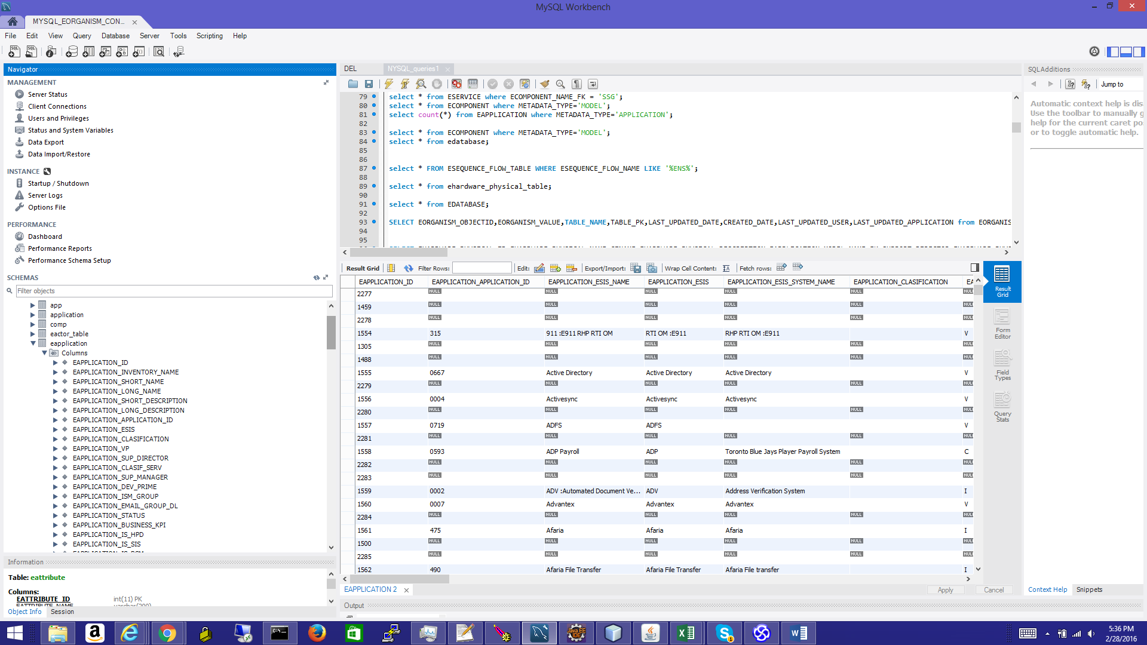

**Enterprise Hardware, servers Inventory**

**EAPPLICATION, EHARDWARE_PHYSICAL**

DB schema

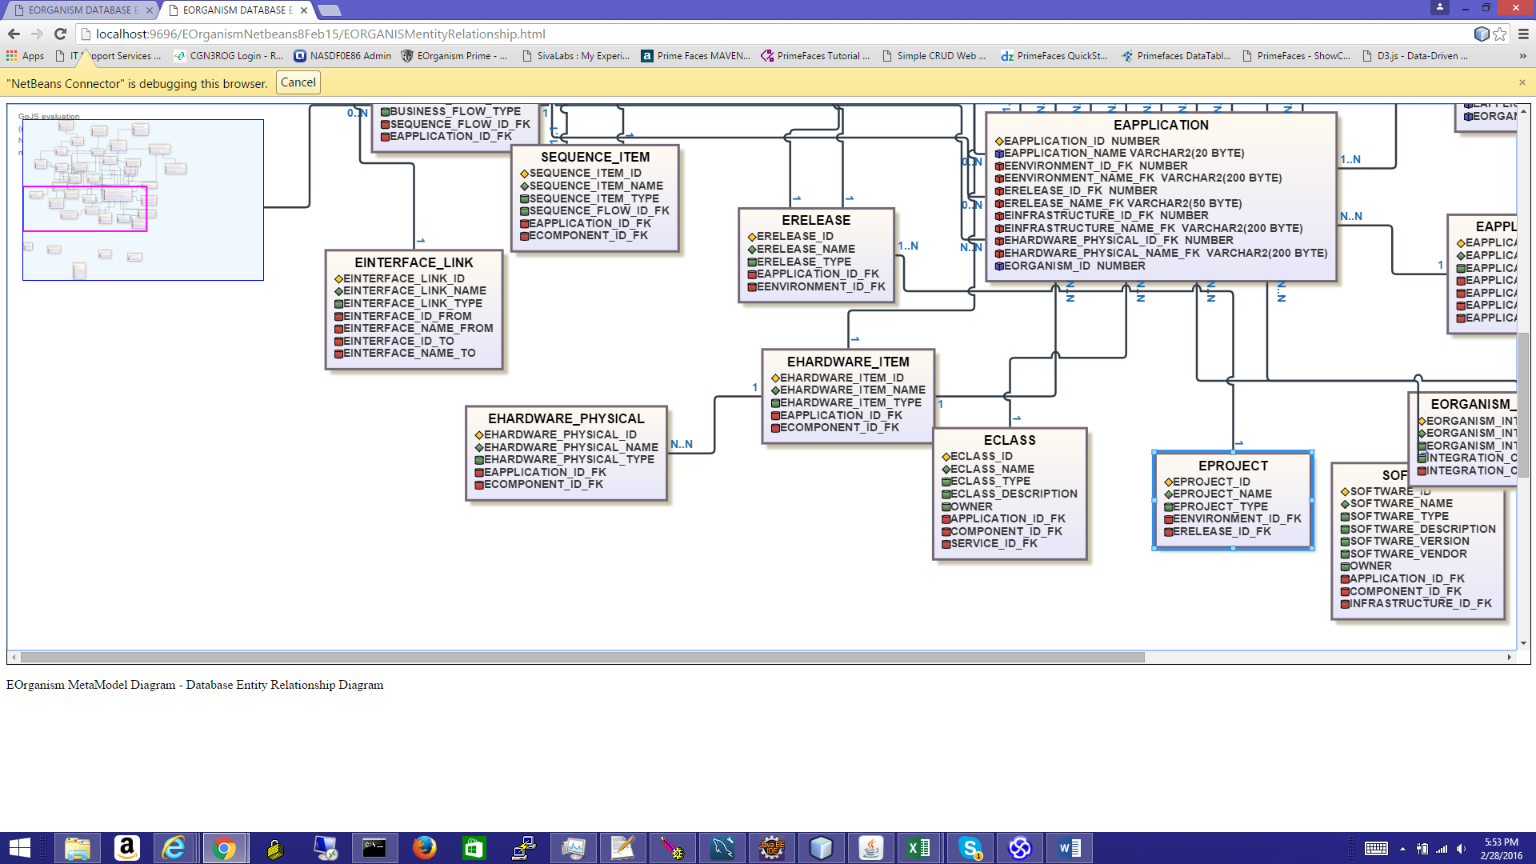

CSV files Servers hardware inventory loader file

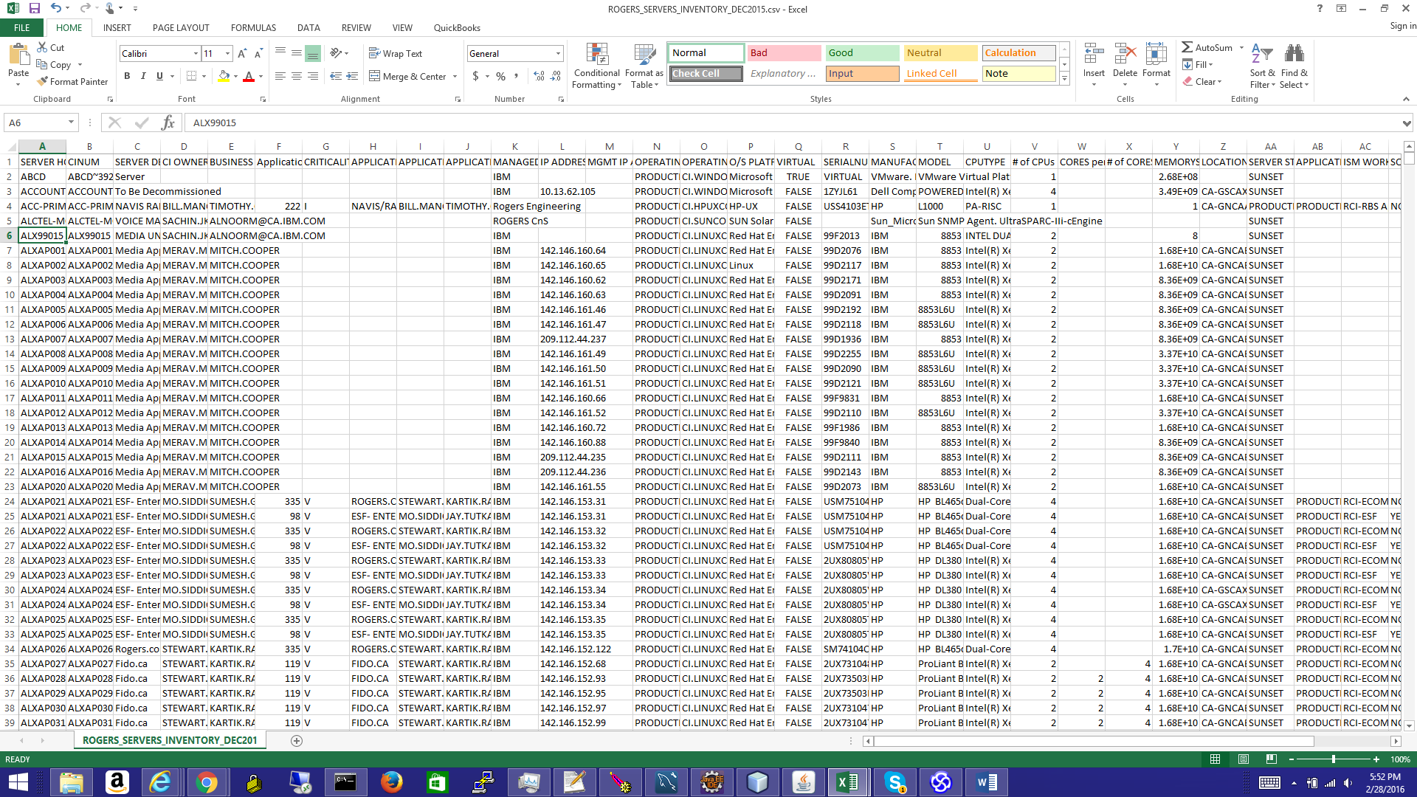

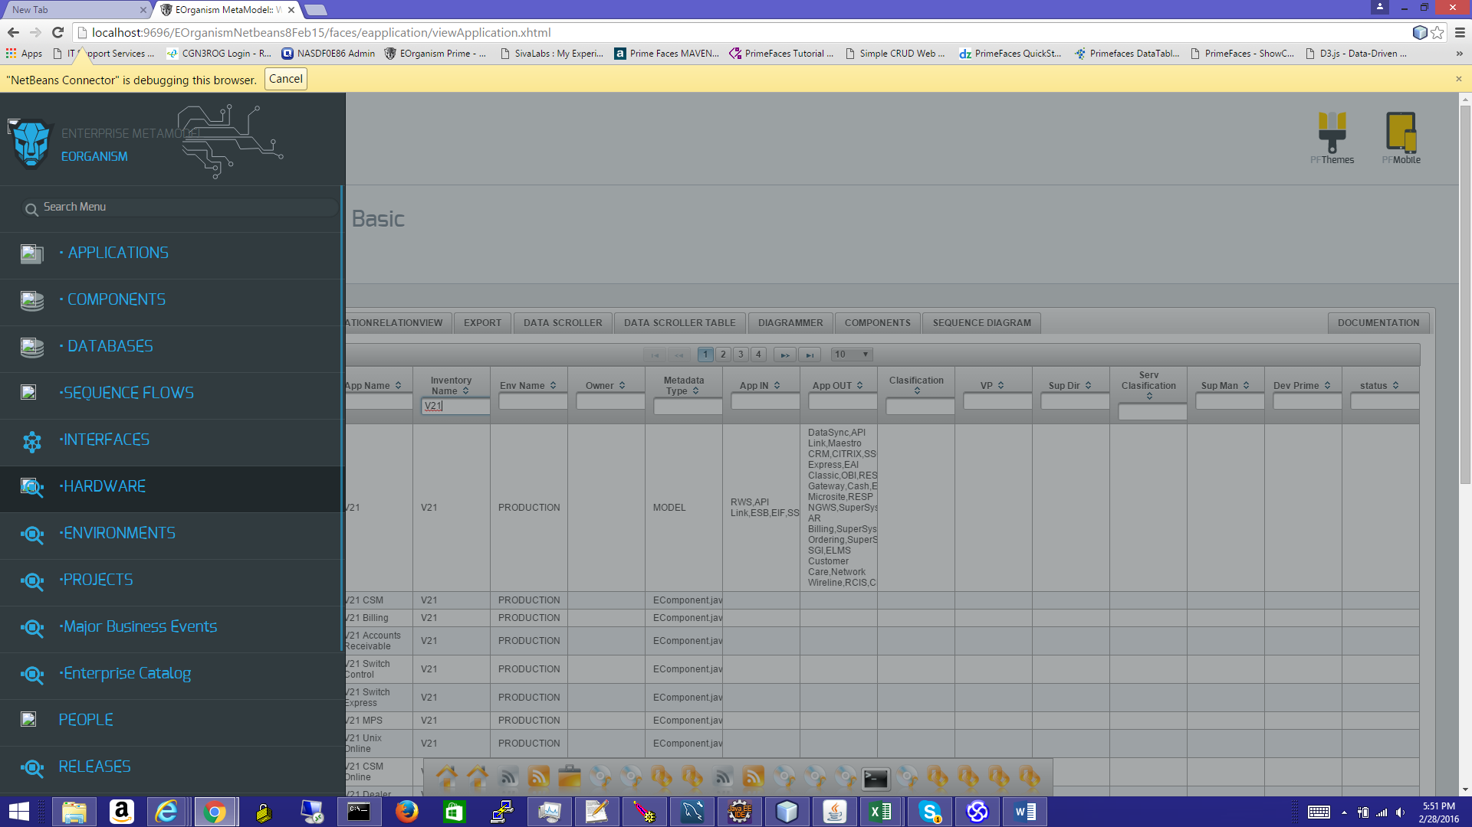

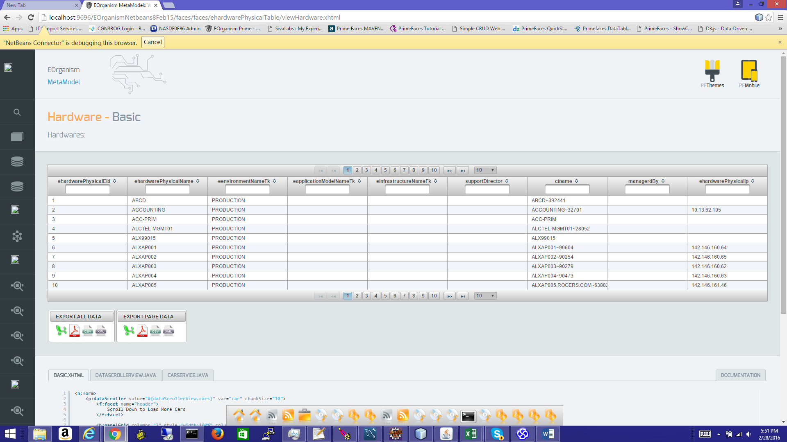

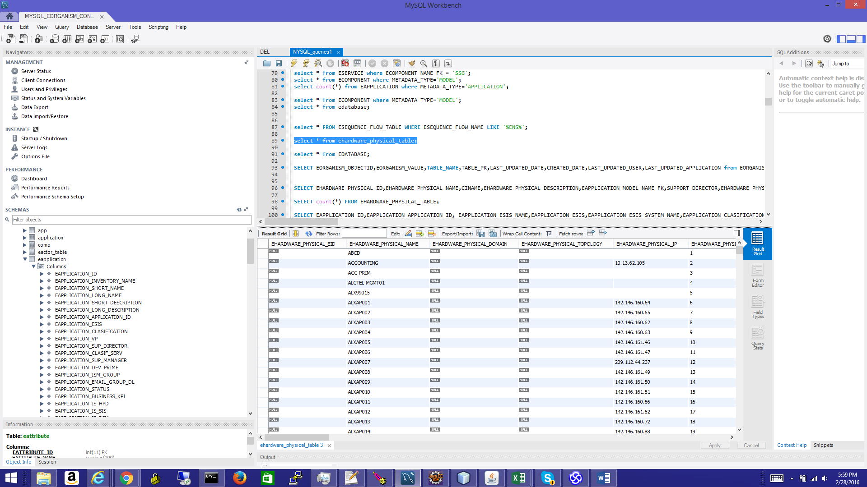

**Enterprise Database Hardware, servers Inventory** – similar to load servers’ inventory list

**Load all DB Enterprise Schemas into a centralized data model** – **TOGAF Enterprise Data Metadata**

**Load all Enterprise SOA and Web services:**

*Similar SOA Web Service Enterprise Repository is provided by Oracle. Oracle Enterprise Repository will require setup each WSDL URL endpoint manually (similar in procedure with SOAP-UI WSDL loded); Oracle Enterprise Repository doesn’t have an enterprise batch function to allow sync and scanning of all URL WSDL from a defined list.*

**EAPPLICAITON, ECOMPOENT, ESERVICE, EINTERFACE, EATRIBUTE**

This SOA WS registry function will load automatically all Web Services, operations/ attributes from deployed WSDL URL locations, real-time.

CSV loader file will load then each WSDL URL will be loaded in automatically parsed. Thus EOrganism will parse and extract operations for each Web Service – e.g. 1800+ independent Web Services.

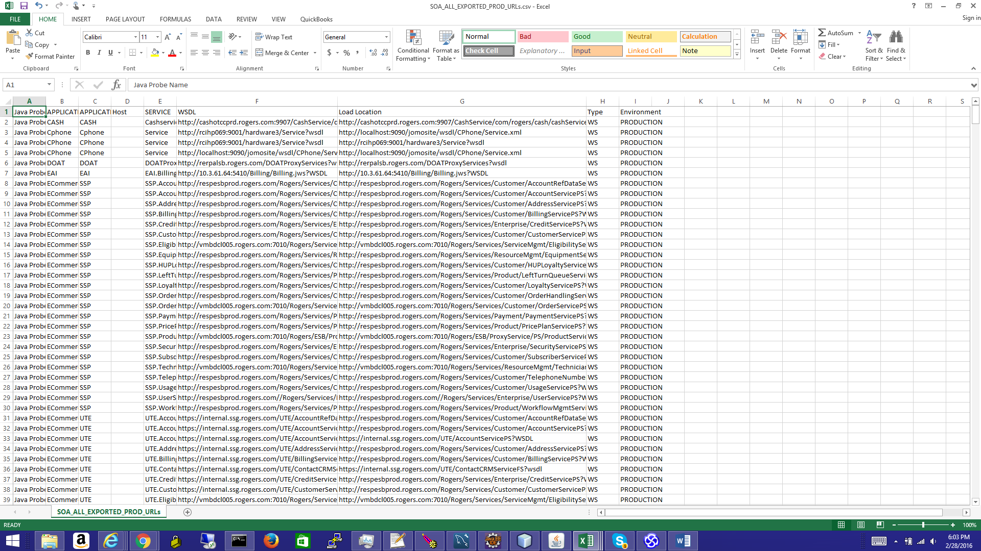

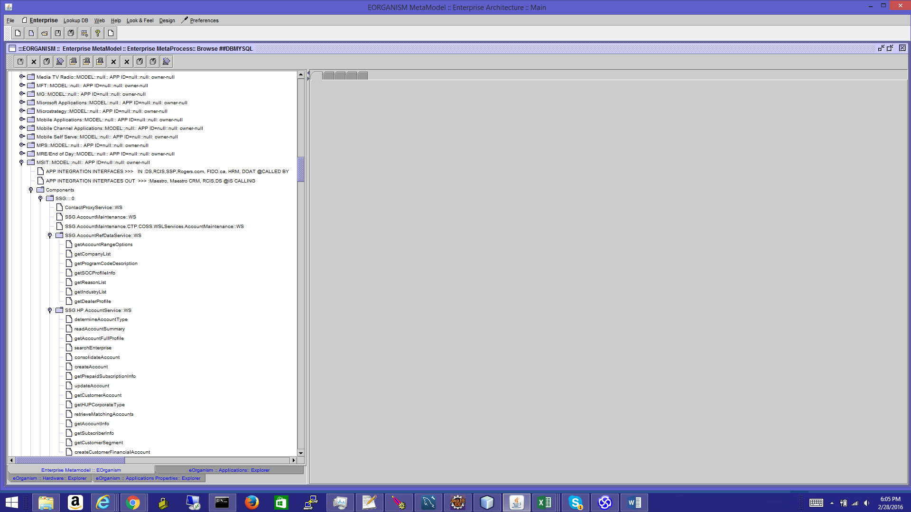

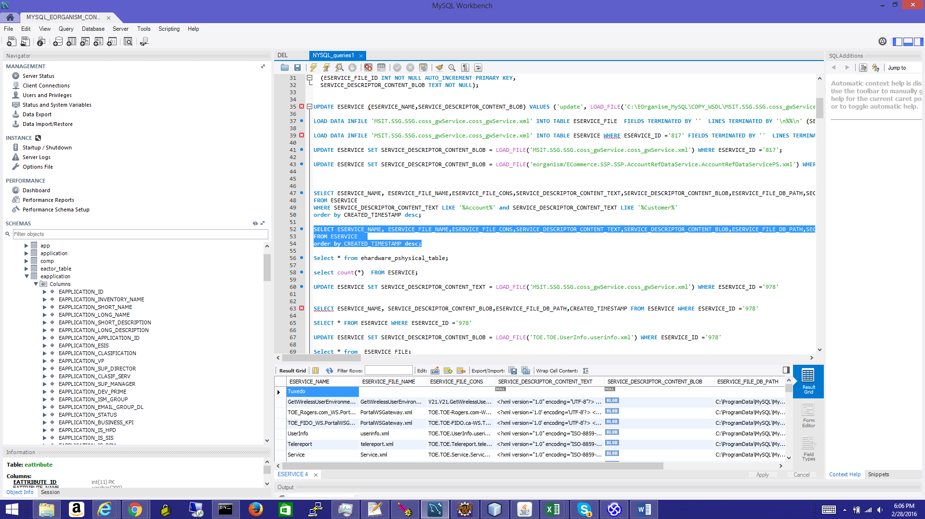

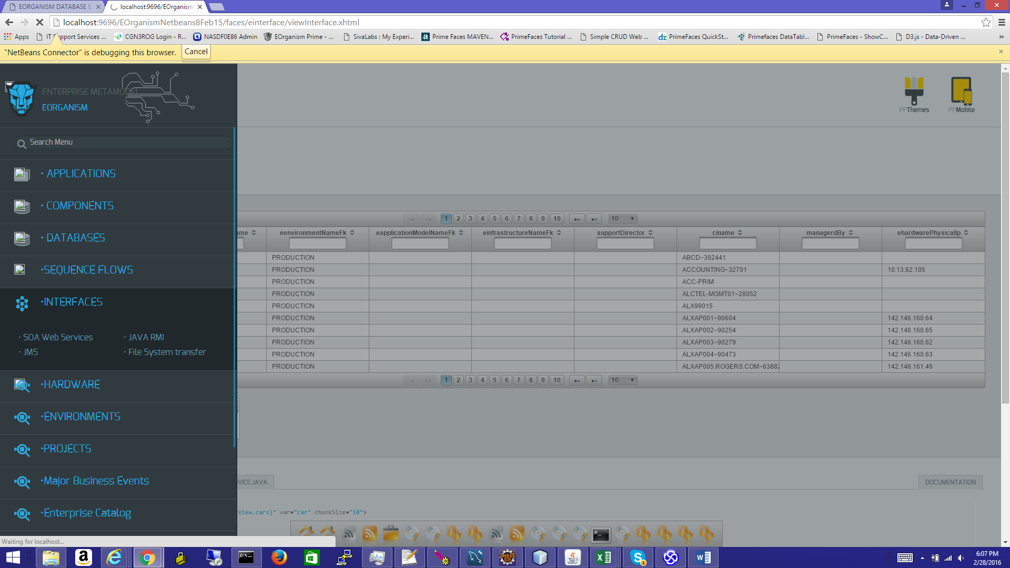

All Web Services interfaces will be available for search and lookup, all across the enterprise.

Each Web Services operation will be available for search, and available to introspection

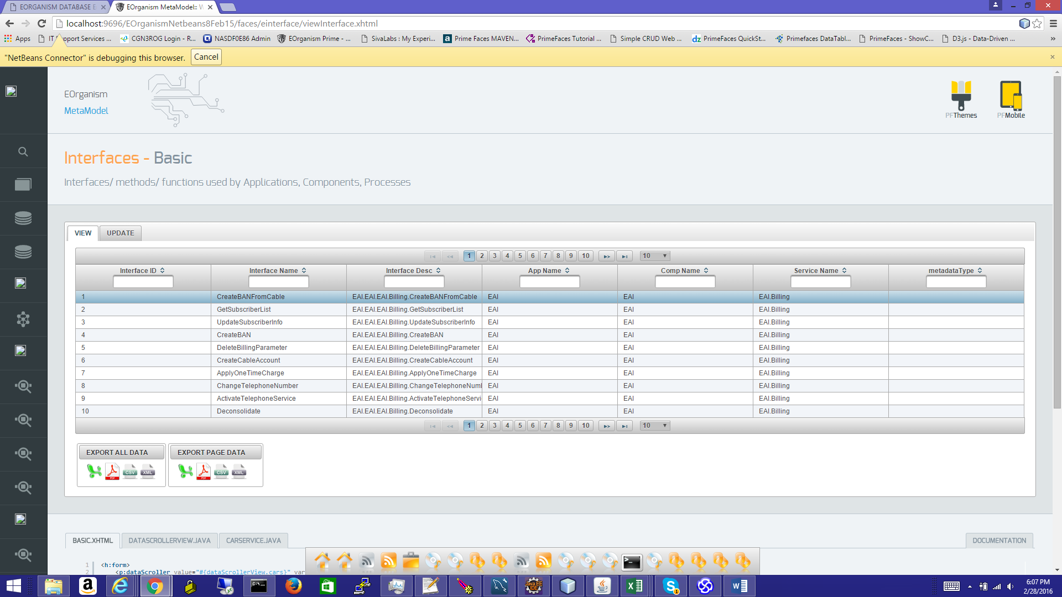

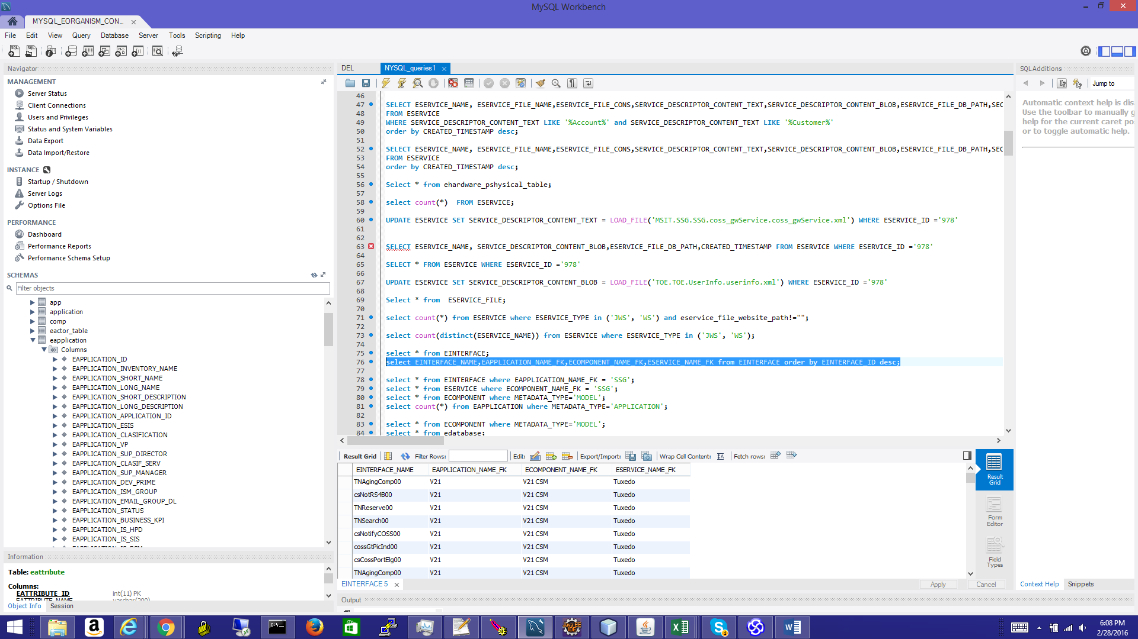

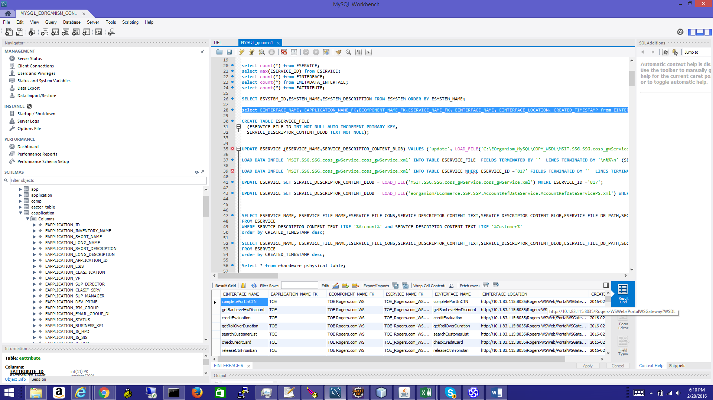

SERVICE WSDL XML file content is loaded in the DB; WSDL URL is recorded, and if HTTPS WSDL WS, then the SSL Security certificate content and details are also loaded.

Each operation SERVICE WSDL XML is also loaded in the DB; operation URL is recorded.

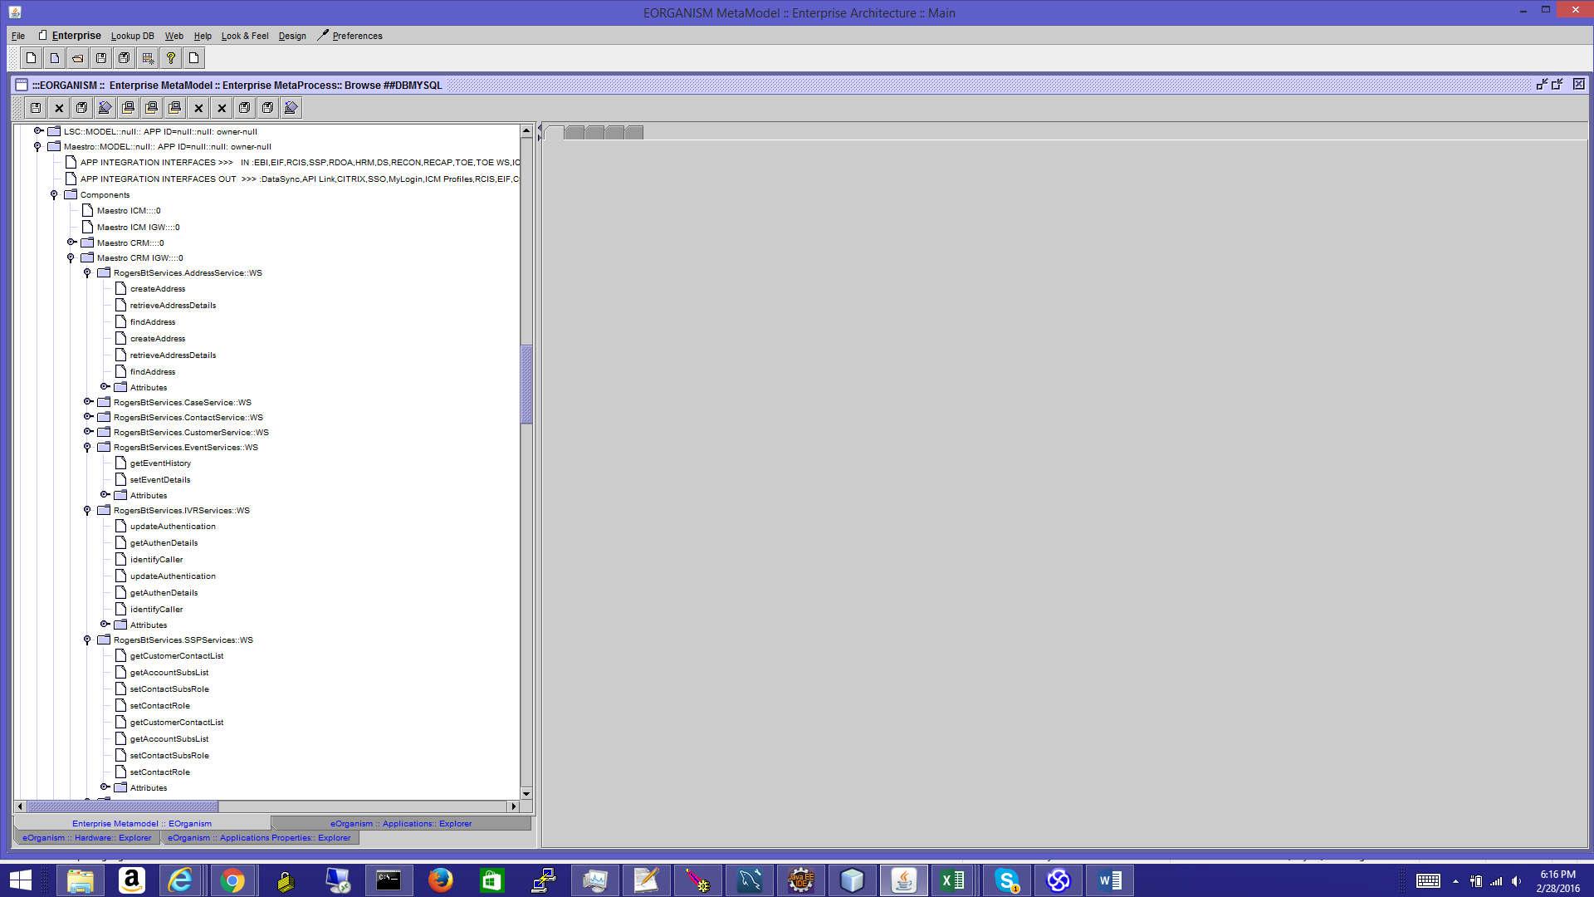

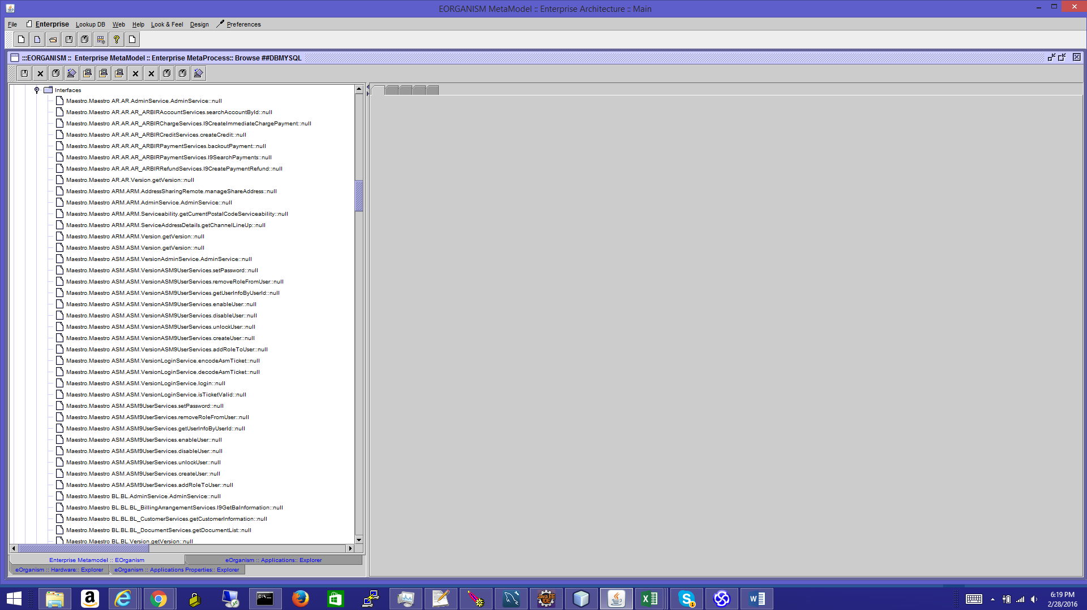

All WSDL operations attributes are also loaded in the DB.

*This is a similar SOAP-UI functionality but extended to thousands or Web Services, will all WSDLs content loaded or sync one time; all details are loaded into a Relational DB and exposed using a Web Interface and easy for metadata search.*

Same Inventory WS endpoints are a repository and clear Environment monitoring and environment maintenance.

**Load all Enterprise Services:**

EOrganism will also load all operations/ services from a CSV list

Tuxedo Operations

RMI – Java RMI remote method invocation operations

CTRL-M jobs, or any kind of list based operations

CTRL-M jobs loader

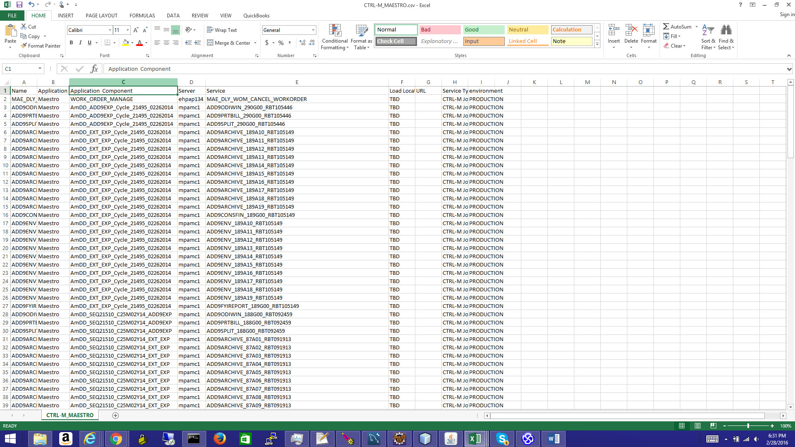

Messaging Oracle (BEA) Tuxedo methods – middleware messaging

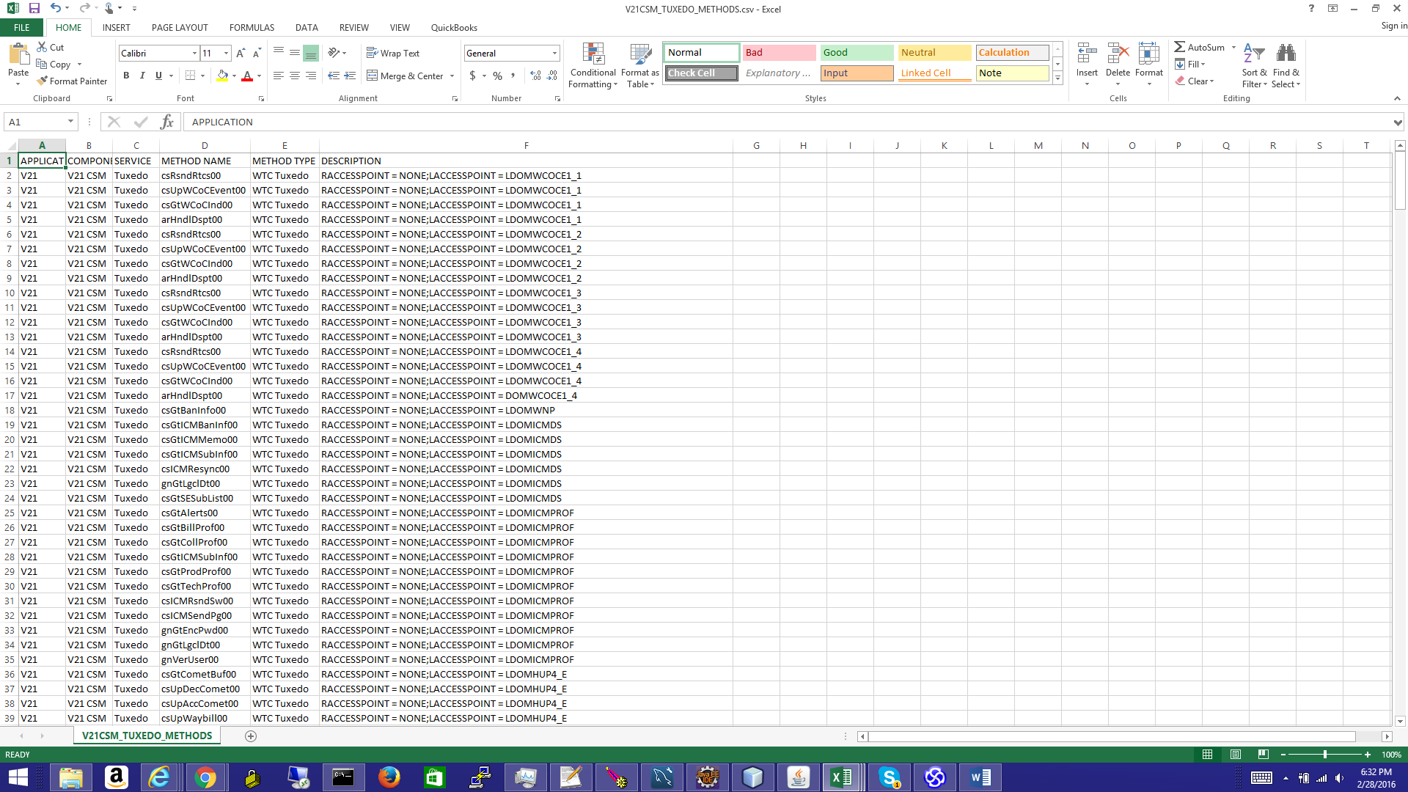

**User case to load Data Model from already extracted DB DDL** – DB Tables and DB Columns. (Use case is similar on loading all schemas Tables, columns- for a given list of DB schemas – connector string provided)

**Data will be loaded in the METADATA_TABLE, METADATA_COLUMN**

1. **Open EOrganism > Enterprise> LOAD Command XML file** then browse to lookup a DB loader file – in this case we load individual Schema table for a CRM DB model-

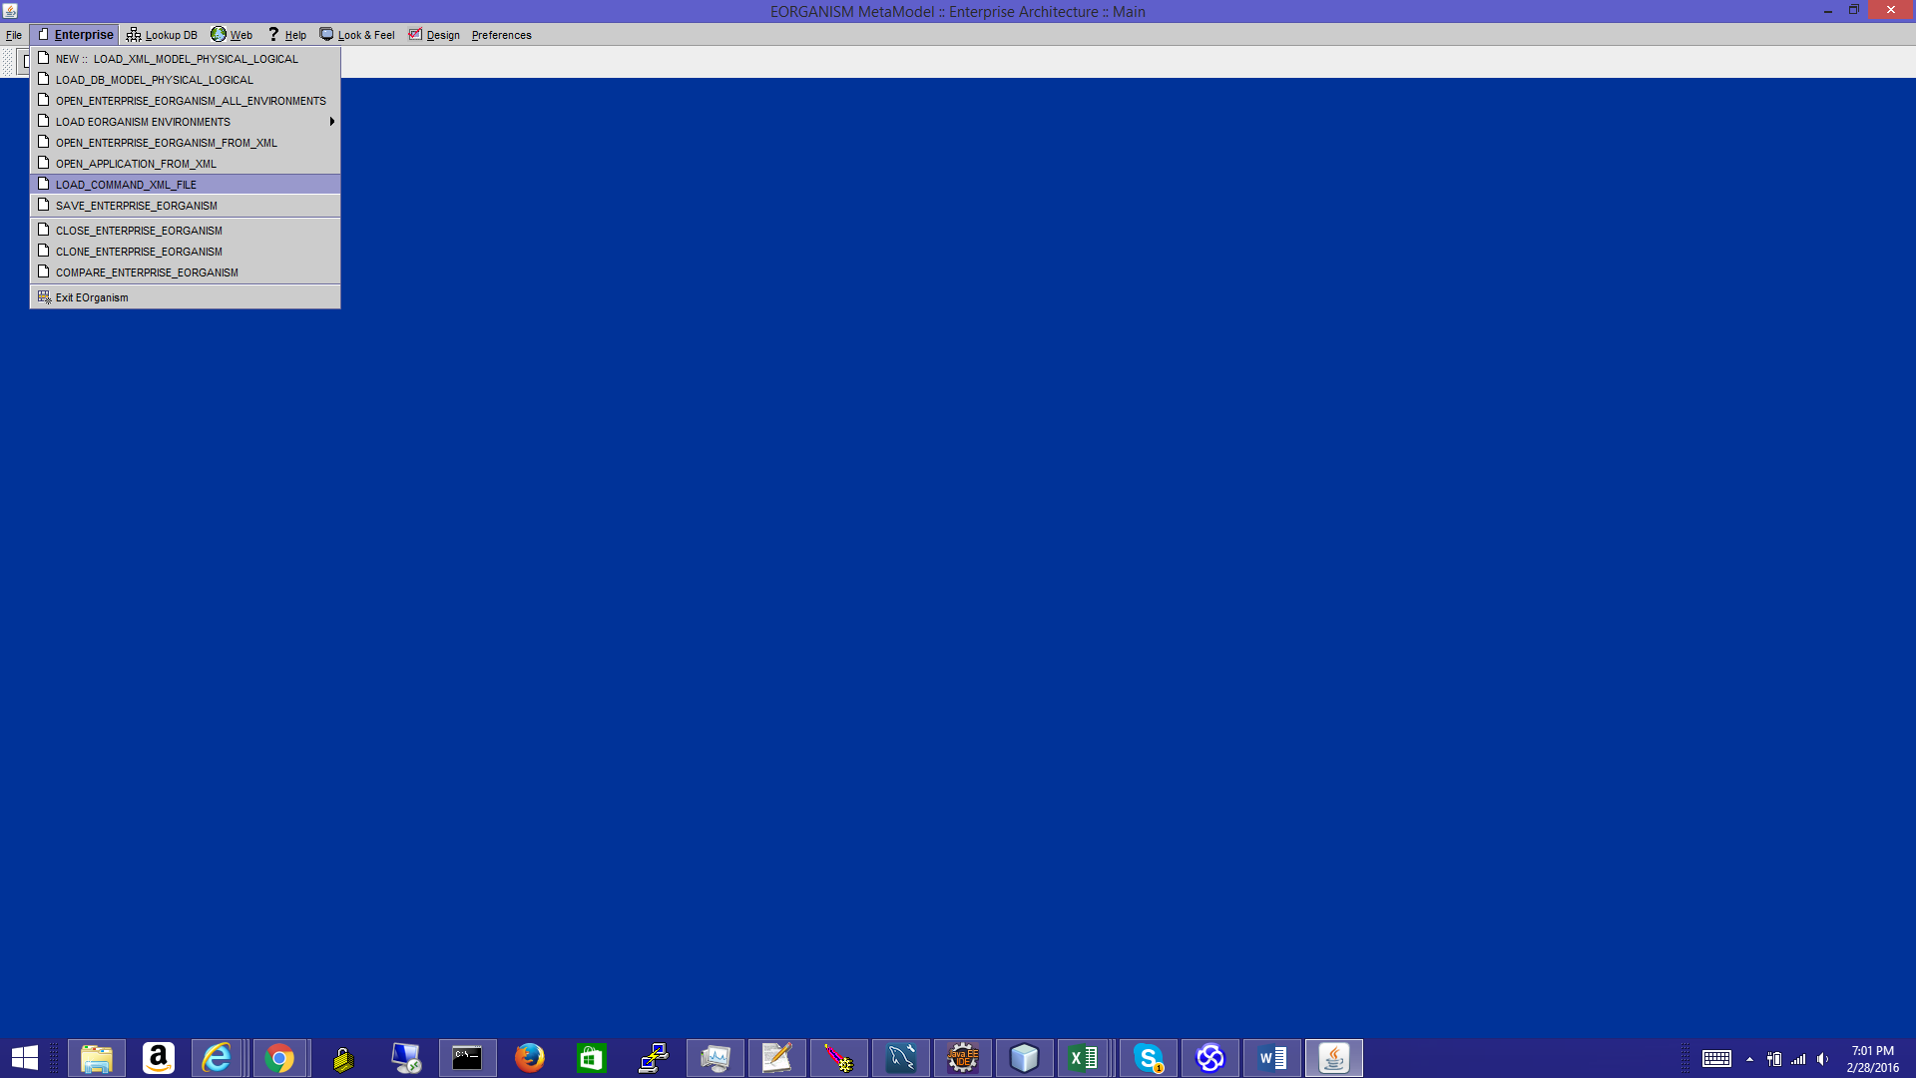

CSV format for loading TABLES

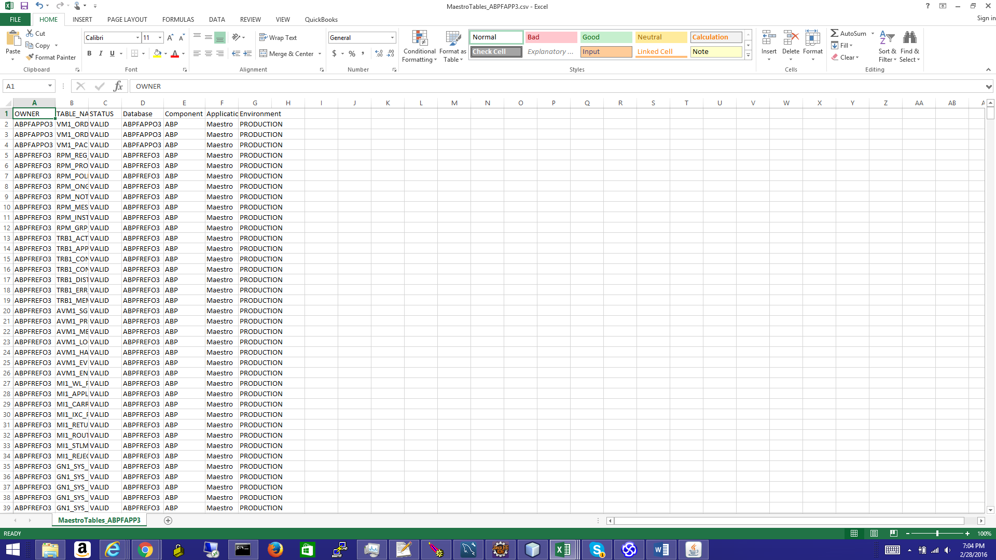

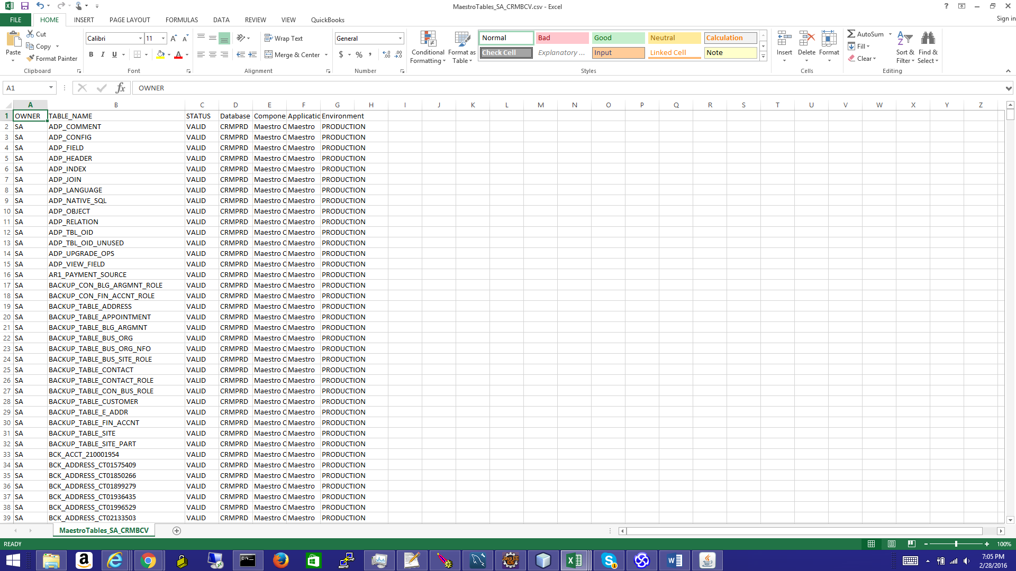

CSV format for loading COLUMNS

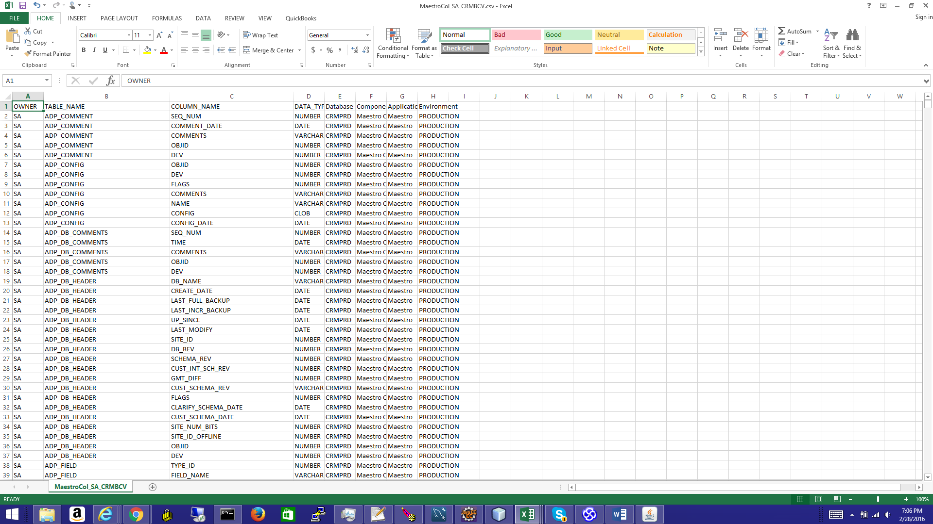

Locate the COMMANDER XML file then load the COMMANDER XML

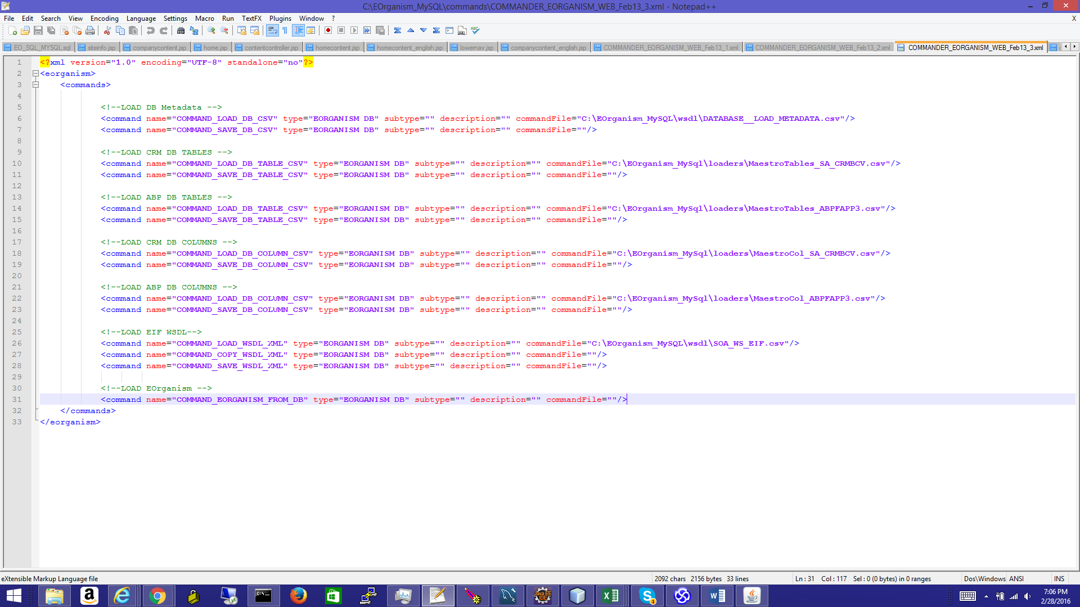

Then EOrganism will start loading; TABLES and COLUMNS in the METAMODEL for the specified schemas in the COMMANDER XML.

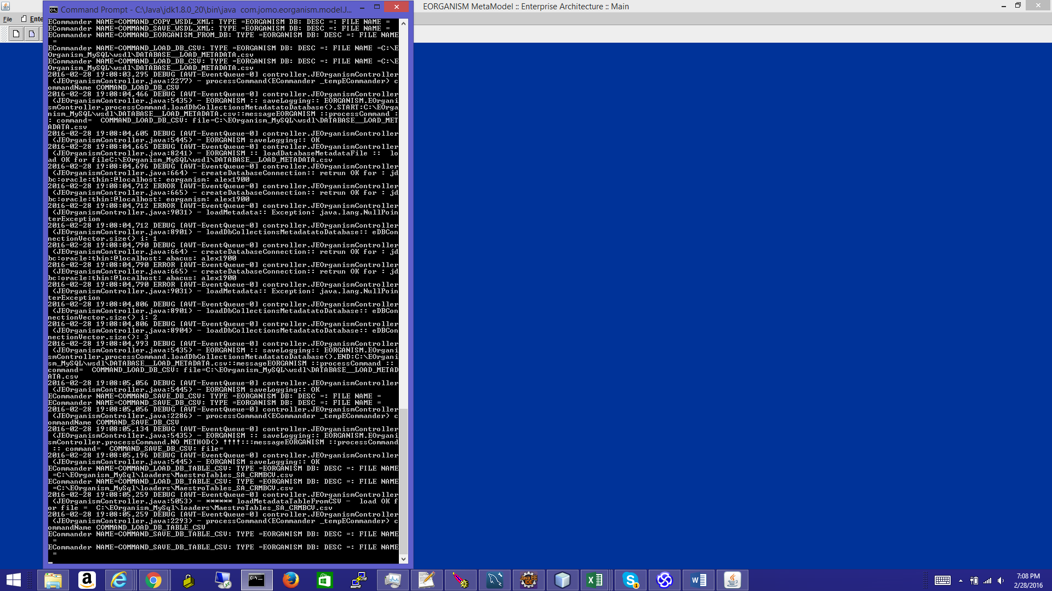

Result can be seen once EOrganism will load from the EOrganism DB, and the loaded schema can be browsed into the database TreeView schema DB view:

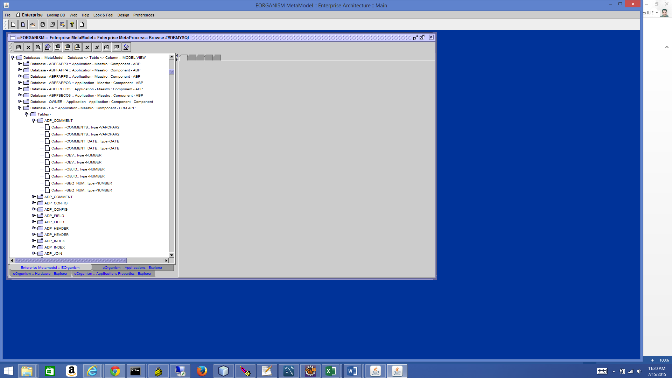

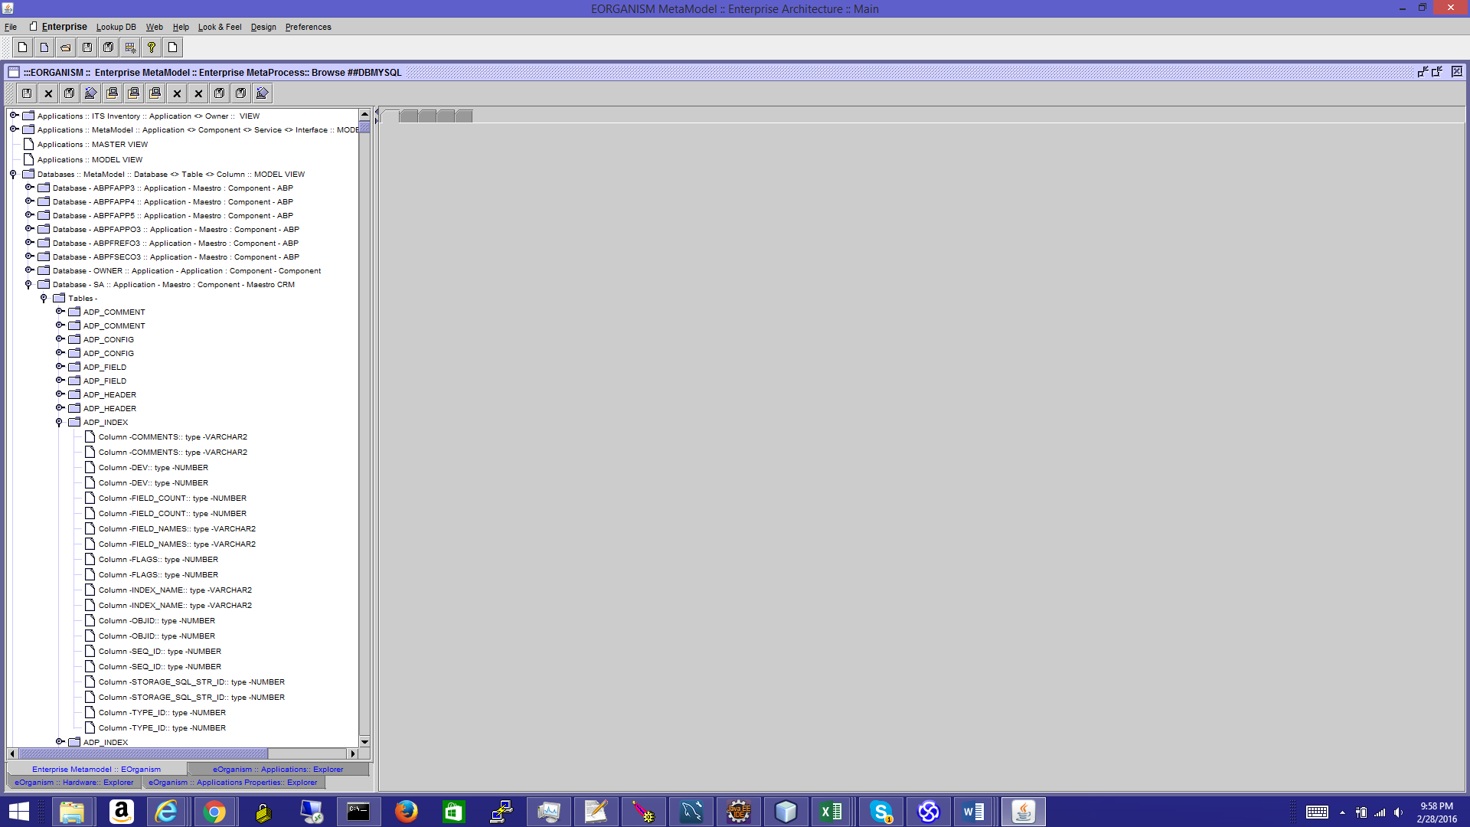

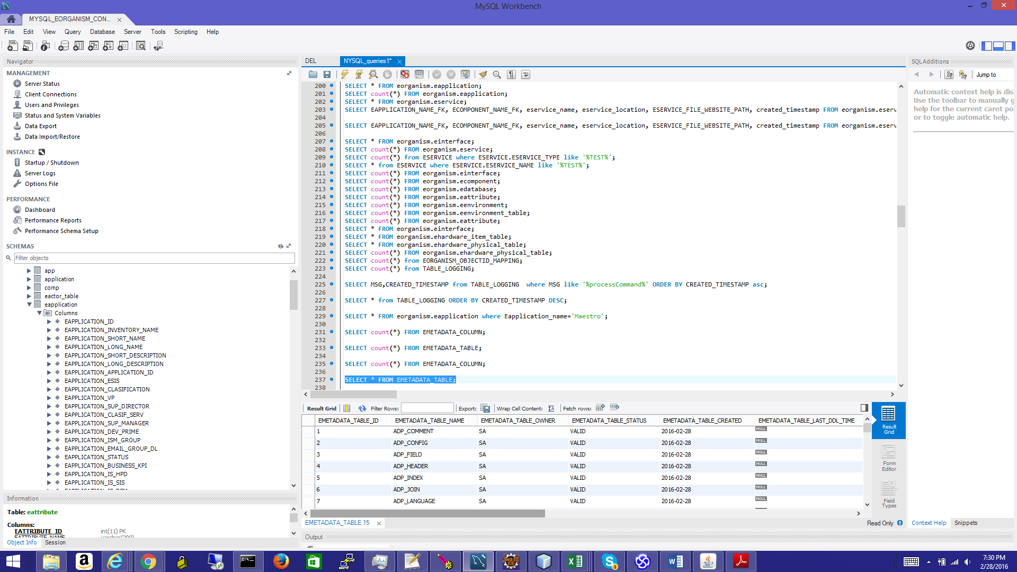

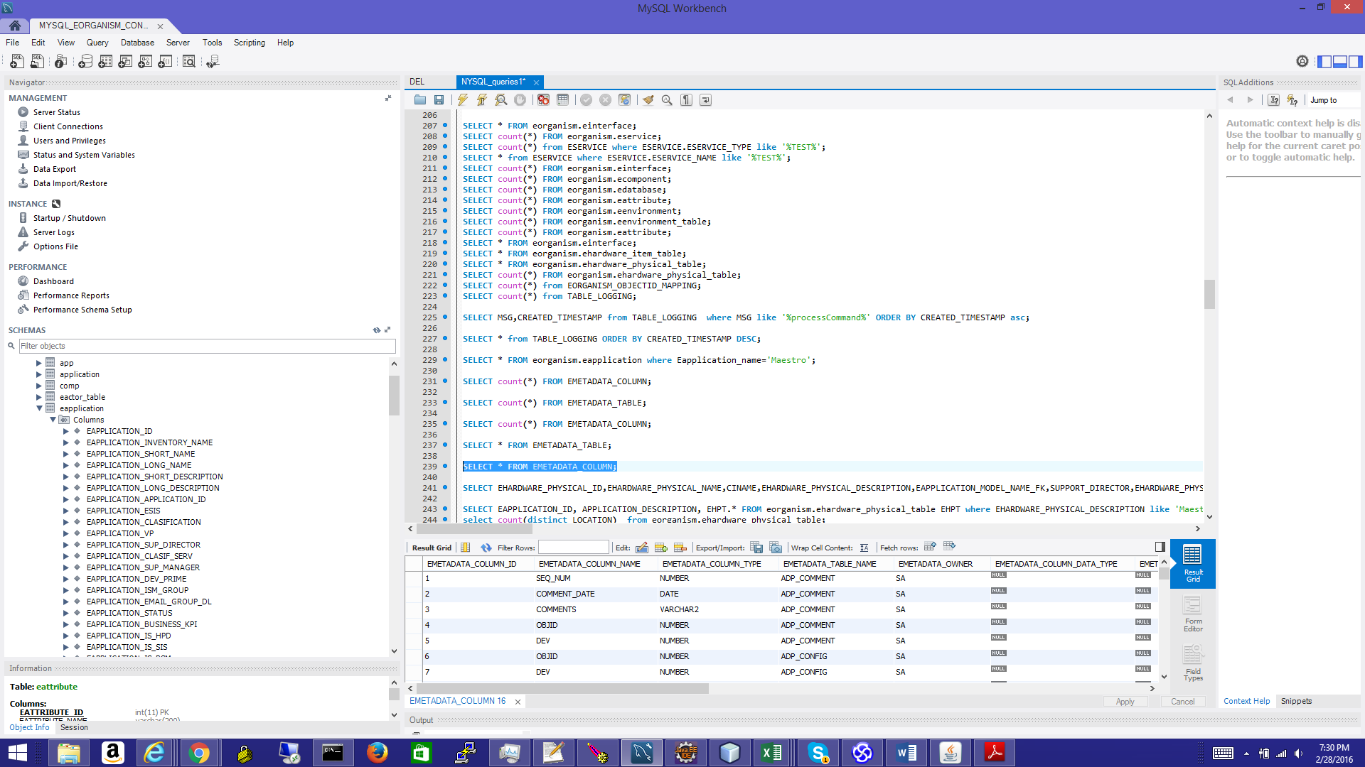

**EOrganism Business Value Propositions:**

1. EOrganism will allow an ultimate an complete information consolidation in the Enterprise – in principle quick enterprise searches, assessment can be performed on the spot; sort of Google Search but performed for the Enterprise Search in IT context; Entities, Enterprise Services and Enterprise data; streamline and properly document the information from Business to the IT levels and reverse. Business initiatives will reach maximum agility from quick and exact detailed/information from IT response. Projects POC and T-shirt estimates can be completed in hours by Business Architects instead of months; standard manual process and SDLC will engage and involve multiple teams in useless, costly, time consuming and unproductive JAD assessment CAPEX meetings, struggling to find the interfaces, flows and data required. Solid documentation using SDS, DDD si difficult to complete under short deadlines and is never detailed enough. Estimate saving 20-30% or total IT costs.
2. EOrganism will allow an exact mapping between Business, Business units and IT Applications, Systems, Interfaces and flows. This visibility and exact information will save 5% of all IT Time.
3. EOrganism will allow a clear Applications integration and real time diagram generation. This documentation available instant at the fingertip, (any data, anywhere, anytime) – will make development, environment setup, production setup very clear. An Enterprise Applications monitoring **VIEW** can test all enterprise URLs, HTTPS, Application login pages, WebLogic Admin Consoles, All DB TNS listeners, in one single execution sync, and extract in one single page view. All HTTPS Certificates can be scanned for expiration in one single sync, in few minutes. Enterprise will not be reactive and will be proactive. All WSDL WS XMLs and Schemas can be scanned for availability and content in minutes – this will provide a supreme production support ability. WSLD WS can be compared in between environments. PROD, non-PROD. Centralized QA Test cases can be documented and properly saved and used. A repository of all Test cases can be easily created. Centralized repository of all Application integration can be created; all sequence flows can be documented to generate all require regression test cases…
4. Business Intelligence and reporting will be easier as each column will be available in Web Based repository similar to TOAD Schema browser, or SQL developer Schema browser for one single schema- but for all schemas. This is an enterprise data and metadata consolidation and also Reporting and DB flows (DB Links or DB batches will be documented).
5. EOrganism will operate with TOGAF MetaModel **VIEWS** – any kinds or combination of custom view (reports) can be setup to extract any information in seconds; e.g. All servers with window 2014 OS; all servers with LINUX OS (requiring probably a patch); all costs associated with a Data Center (servers located to a particular datacenter).
6. EOrganism will have roles: EO ADMIN, APP ADMIN, APP ARCHITECT, ENTERPRISE ARCHITECT, SECURITY ARCHITECT, EO APP ADMIN, DBA, DB DEVELOPER, APP DEVELOPER, PM,
7. EOrganism solution is a Cloud based without requiring any infrastructure and setup from the companies and associated IT departments. Internal Cloud based solution can be easily setup and maintained.
8. EOrganism will have LDAP, SSO functions and API for SSO integration – Federated SSO services.
9. All EOrganism Loading functions, loader files, commander XML files and updates can be performed directly from Web Admin interfaces.
10. A tool like EOrganism properly implemented will allow significant cost reduction all across IT; up to 40% of all IT costs

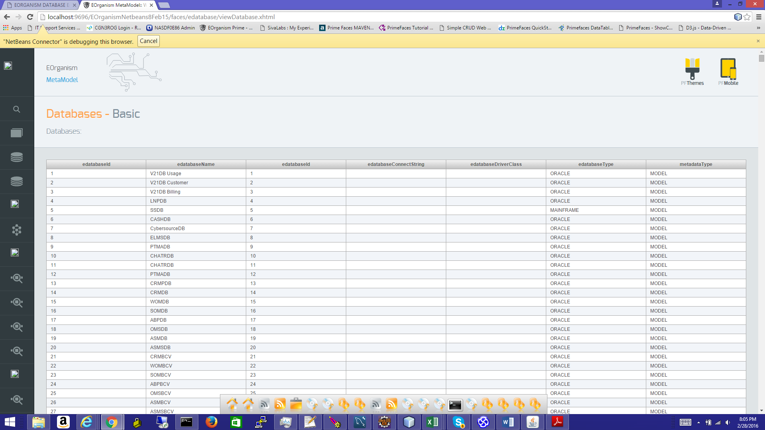

**EOrganism Visualization and EOrganism Graph Visual Search**

Java Swing GUI

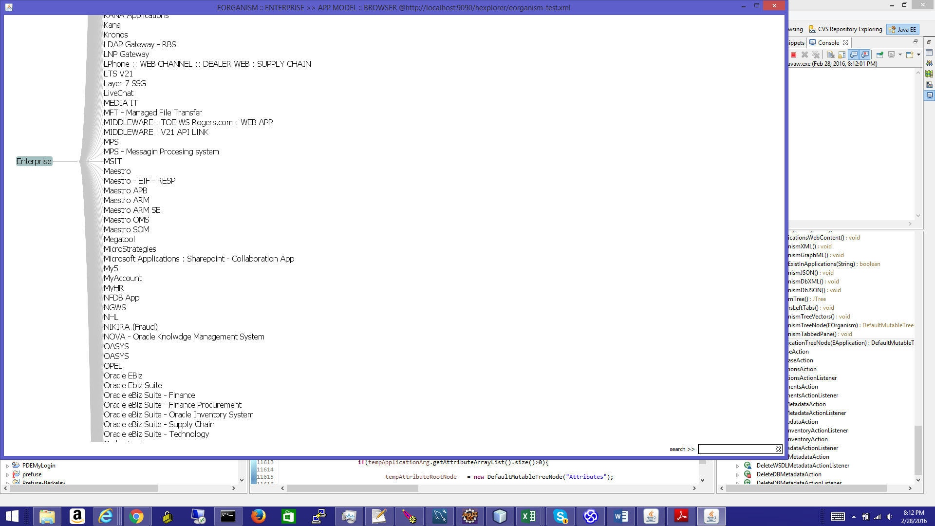

Browse in graph tree

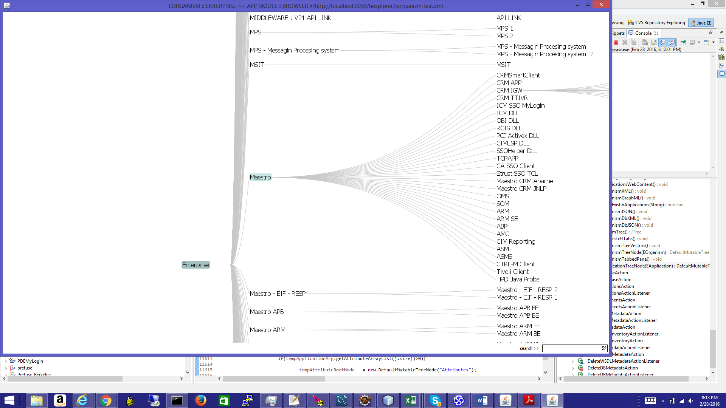

Go to interface level in graph

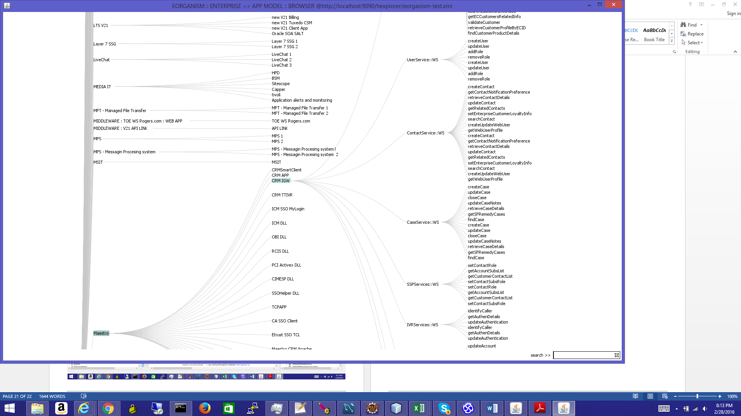

Graph visual interface search

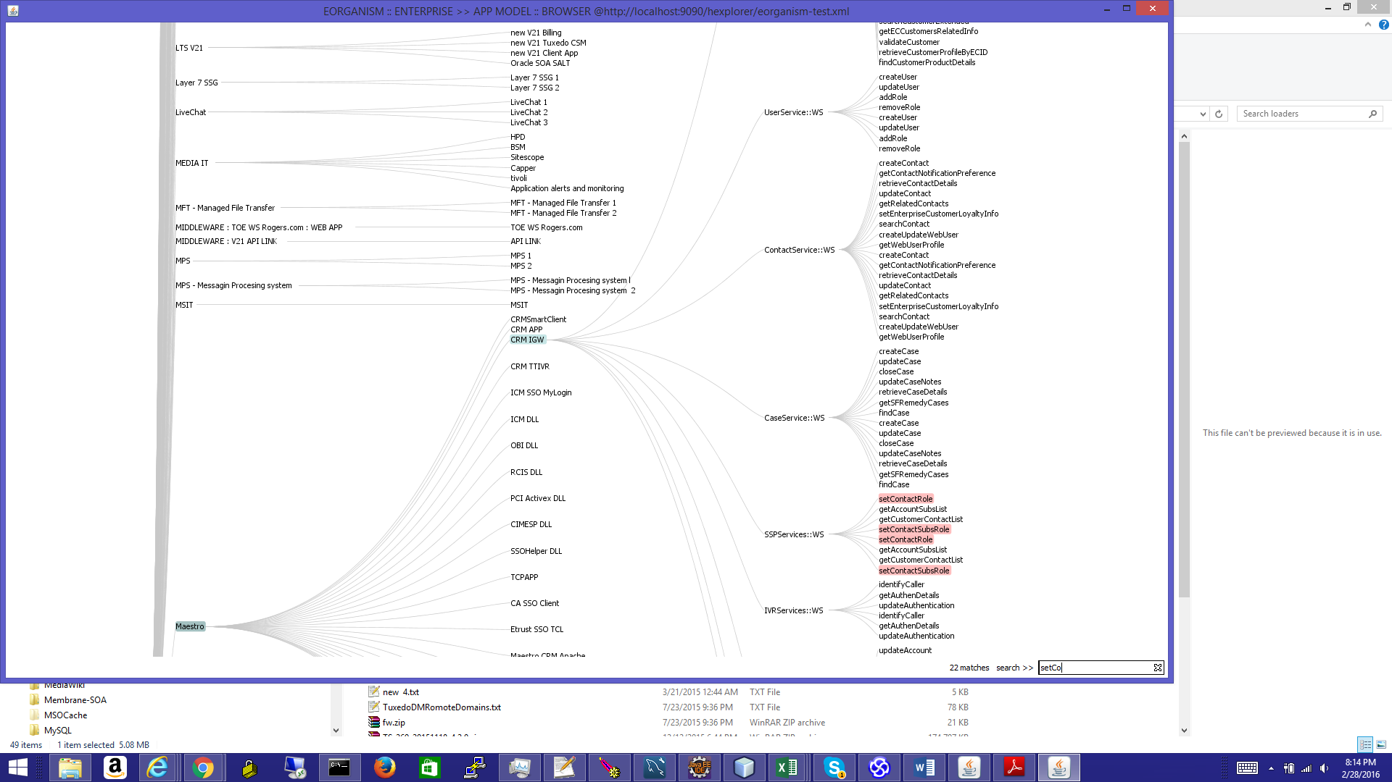

Zoom in the Enterprise Tree

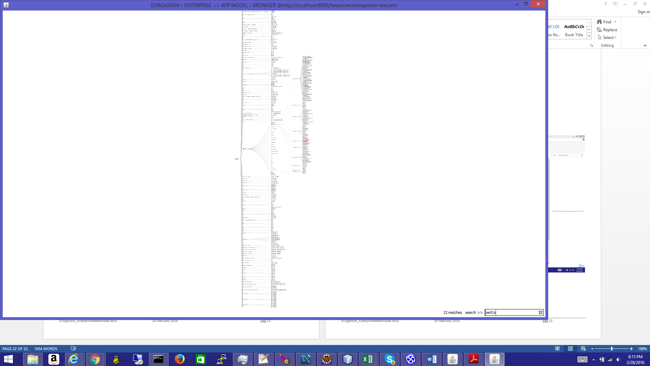

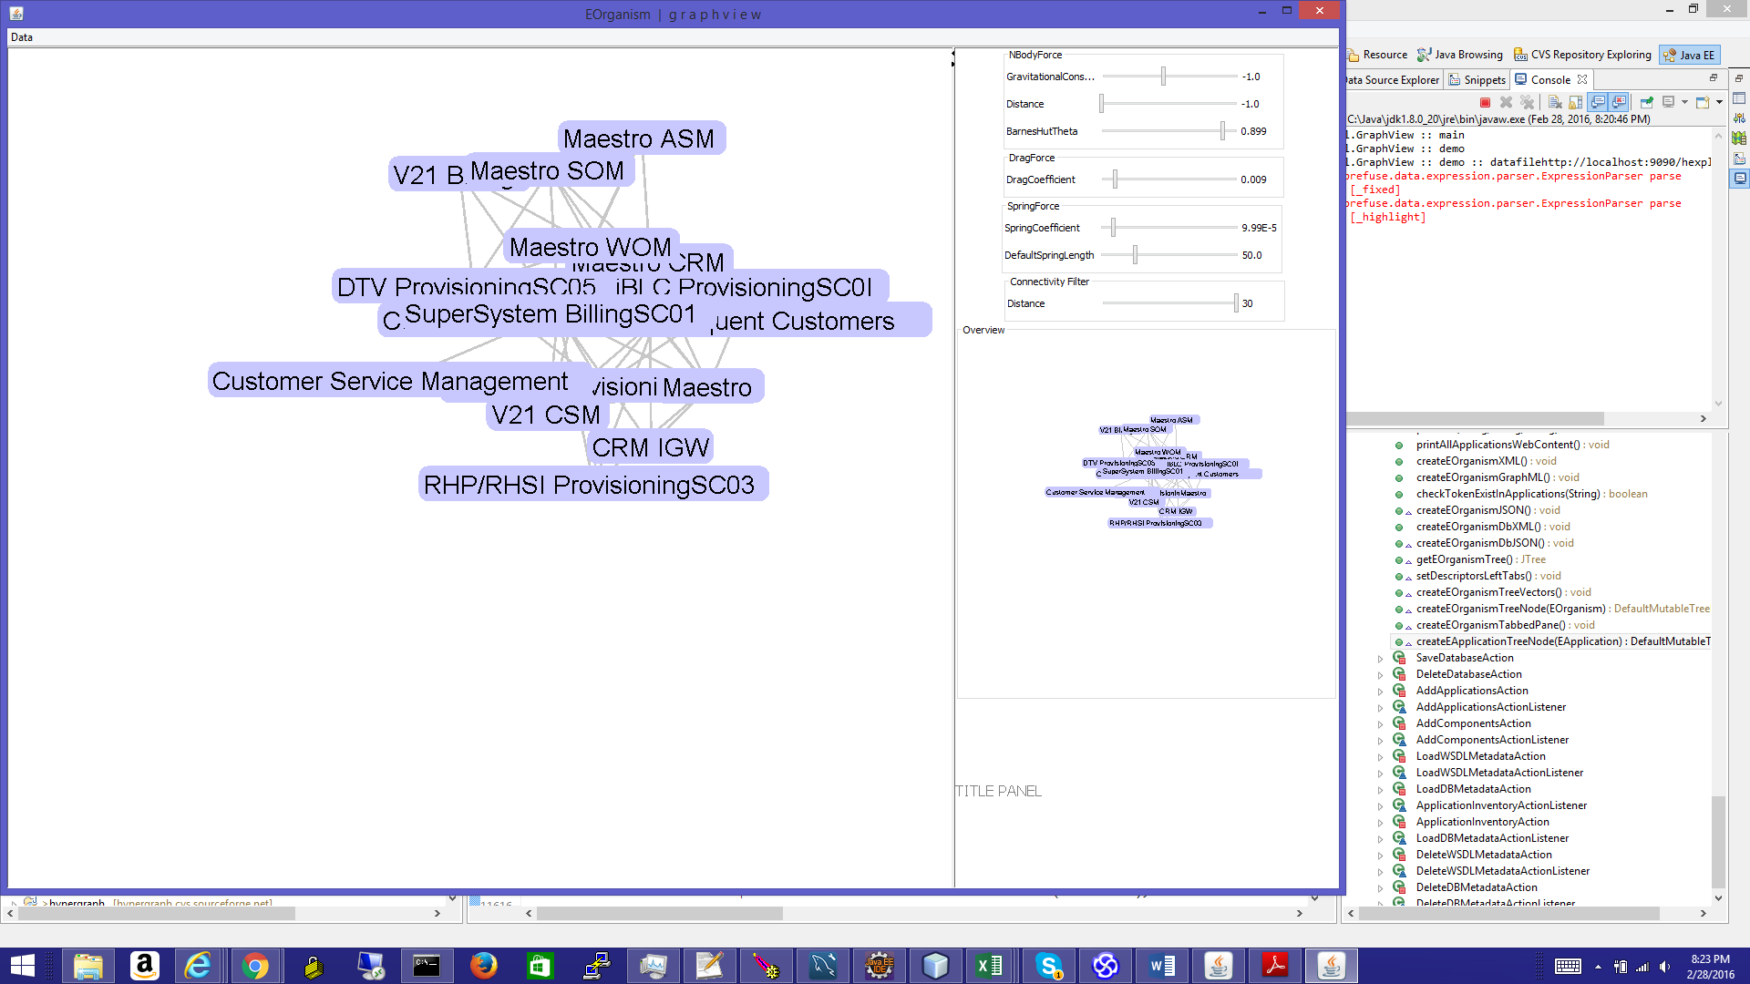

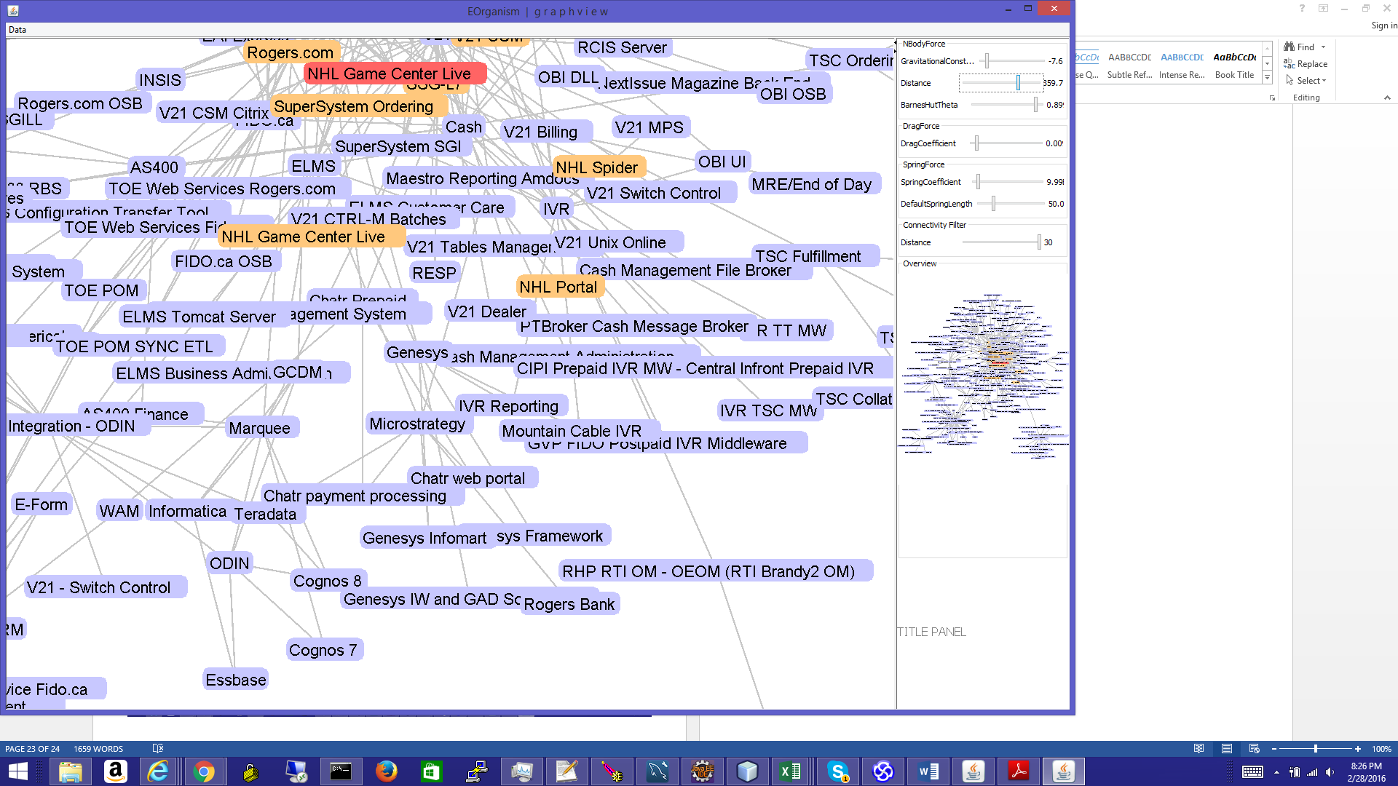

A Web Bases Graph view, browser based vizualisation:

